
Hill College
EMS Education P r o g r a m

Paramedic Student Handbook

Student Name:

Course Rubric: EMSP Course Number: CIP: 51.0904

***This Page Left Intentionally Blank***

Table of Contents

Medical Director Approval of EMS Education Program Handbook 7
Article 1 EMS Education Program Accreditation Statement 8
Article 2 Welcome to the EMS Education Program at Hill College 9
Section 2.01 Program Goal 9
Section 2.02 Program Philosophy 9
Section 2.03 EMS Code of Ethics 10
Section 2.04 Emergency Medical Services Functional Job Description 11
Article 3 Hill College Policies/Procedures (Institutional) 13
Section 3.01 Introduction 13
Section 3.02 Office of Students with Disabilities 13
Section 3.03 Discrimination Prohibited 14
Section 3.04 SACS Accreditation 15
Section 3.05 Transfer of Credit 15
Section 3.06 Reinstated/Transfer Students 16
Section 3.07 Course Withdrawals 16
Section 3.08 Schedule Changes (Add/Drop) 17
Section 3.09 Student’s Role in College Decision Making 17
Section 3.10 Children in Classroom and Labs 18
Section 3.11 Counseling Services 18
Section 3.12 Financial Aid 18
Section 3.13 Library 18
Section 3.14 Testing Centers NREMT – Pearson/Vue 19
Section 3.15 Textbook and Supplies 19
Section 3.16 Parking 19
Section 3.17 Advanced Placement 19
Article 4 Health and Community Services Division Rules/Procedures/Guidelines 20
Section 4.01 Rules/Procedures/Guidelines 20
Section 4.02 Scholastic Dishonesty 20
Section 4.03 Program Progression 21
Section 4.04 Student Complaint/Grievance Procedure 21
Section 4.05 Sexual/Racial Harassment Complaints 22
Section 4.06 Grade Change Policy 22
Section 4.07 Assignment of Grades 22
Article 5 Clinical/Practicum Rules/Procedures/Guidelines 23
Section 5.01 Professional Behavior 23
Section 5.02 Professional Ethics and Confidentiality 23
Section 5.03 Safe/Unsafe Clinical/Practicum Practices 23
Article 6 Health and Safety Information 25
Section 6.01 Professional Risks 25
Section 6.02 Health and Liability Insurance 25
Section 6.03 Accident Procedure 25
Section 6.04 Exposure Response 26
Section 6.05 Clinical Accident and/or Incident Report 26
Article 7 HIPAA 27
Article 8 Emergency Procedures 28
Article 9 Family Education Rights and Privacy Act (FERPA) 28
Article10 EMS Education Program Rules/Procedures/Guidelines 28
Section 10.01 Students with Disabilities 28
Section 10.02 Substance Abuse Rule/Procedure/Guideline 28
Section 10.03 Criminal Background 29
Section 10.04 Admission Requirements 30
Application Process Student Check List 30
TB Testing 30
Student Record Storage Procedure 30
CPR Certification 30
EMT ADVANCED/PARAMEDIC students must meet the following eligibility requirements 31
Texas Success Initiative (TSI) 31
Section 10.05 Grading Policy 31
Section 10.06 Incomplete 33
Section 10.07 Non-Progressing Course Grade 34
Section 10.08 Discipline Rules/Procedures/Guidelines 34
Section 10.09 Service Work Rule Section 35
Section 10.10 Service Course Completion 35
Section 10.11 Withdrawal 36
Section 10.12 Social Media 36
Article 11 EMSP Classroom and Lab Policies 37
Section 11.01 General Behavior 37
Section 11.02 Cell Phones/Pagers/Electronic Devices 37
Section 11.03 Dress Code - Hill Colleges EMS Program Uniform 37
Section 11.04 Attendance 38
Section 11.05 Testing 39
Section 11.06 Lab Policy - NREMT Portfolio & Classroom Skills Labs 40
NREMT Portfolio Skills 40
Article 12 EMSP Clinical Policies 43
Section 12.01 Clinical Professionalism 43
Section 12.02 Clinical Guidelines 43
Section 12.03 Clinical & Field Internship Dress Code 44
Section 12.04 Attendance – Clinical & Field Internship 45
Section 12.05 Clinical Scheduling and Absences 45
Section 12.06 Missed Clinical/Field Internship 47
Section 12.07 Special Situations 47
Section 12.08 Clinical & Field Requirements 47
Paramedic Clinical & Field Requirements Hours 57
Paramedic Practicum Field Requirements Recommendations 58
Section 12.09 Clinical Paperwork 59
Section 12.10 Clinical & Field Internship Grading Policy 60
Article 13 EMS Education Program Information 62
Section 13.01 Program Length and Description 62
EMSP 1160 Basic Clinical Internship-E.M.S. Professions (0-6) 62
EMSP1161 Advanced Clinical-E.M.S. Professions (0-6) 63
EMSP 1162Paramedic Clinical 1-E.M.S. Professions (0-6) 63
EMSP 1163 Paramedic Clinical II-E.M.S. Professions (0-6) 63
EMSP1355 Trauma Management (2-2) 63
EMSP1356 Patient Assessment & Airway Management (2-2) 63
EMSP 1438 Introduction to Advanced Practice (3-2) 63
EMSP1501 Emergency Medical Technician (3-8) 63
EMSP 2143Assessment Based Management (0-3) 64
EMSP 2338 EMS Operations (2-2) 64
EMSP 2348 Emergency Pharmacology (3-1) 64
EMSP 2430 Special Populations (3-2) 64
EMSP 2434 Medical Emergencies (3-4) 64
EMSP 2460 Clinical-Emergency Medical Service Professions III (0-16) 64
EMSP 2544 Cardiology (4-4) 64
Section 13.02 Program Cost 64
Section 13.03 Physical Requirements 65
Article 14 Secretary Commission on Achieving Necessary Skills (SCANS) 66
Article 15 Student Contract Form 69
Hill College Preceptor Training Documentation 70

Rest of Page Left Blank Intentionally

Medical Director Approval of EMS Education Program Handbook

I, Jeff Beeson, DO hereby approve the Hill College EMS Program Handbook and all rules/guidelines and procedures set forth.
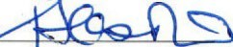
Jeff Beeson DO.
EMS Education Program Medical Director Hill College EMS Education Program

Article 1 EMS Education Program Accreditation Statement
"Hill College is accredited by the Commission on Accreditation of Allied Health Education Programs (www.caahep.org) upon the recommendation of the Committee on Accreditation of Educational Programs for the Emergency Medical Services Professions (CoAEMSP)."
CAAHEP:
Commission on Accreditation of Allied Health Education Programs 1361 Park Street
Clearwater, FL 33756
727-10-2350
www.caahep.org
CoAEMSP:
8301 Lakeview Parkway, Suite 111-312
Rowlett TX 75088
(214) 703-8445
FAX (214) 703-8992
www.coaemsp.org

*THE REST OF THIS PAGE INTENTIONALLY LEFT BLANK*

Article 2 Welcome to the EMS Education Program at Hill College

Hill College empowers student learning and community enrichment through quality education.

Section 2.01 Program Goal
“To prepare Paramedics who are competent in the cognitive (knowledge), psychomotor (skills), and affective (behavior) learning domains to enter the profession.”

Section 2.02 Program Philosophy
The Hill College EMS Education Program prepares students to care for people in the pre- hospital setting. The focus of this educational process is on developing students' critical thinking assessment, rendering the best treatment plan for the patient both on scene and during the patient’s transport to a medical facility.

Being a pre-hospital provider takes a certain kind of individual. Successful emergency medical professionals must demonstrate:
- Respect
- Integrity
- Empathy
- Self-Motivation
- Professional Appearance and Personal Hygiene
- Professional Maturity and Self Confidence
- Good Communication and Critical Thinking Skills
- Time Management Skills
- Teamwork and Diplomacy
- Patient Advocacy
- Careful Delivery of Service
- Excellent Physical Conditioning
- Strong math and sciences background.

*THE REST OF THIS PAGE INTENTIONALLY LEFT BLANK*

Section 2.03 EMS Code of Ethics
Professional status as an Emergency Medical Technician and Emergency Medical Technician - Paramedic is maintained and enriched by the willingness of the individual practitioner to accept and fulfill obligations to society, other medical professions, and the profession of EMS.
As an EMT-Paramedic, I solemnly swear myself to the following code of professional ethics:
A fundamental responsibility of the EMT-P is to conserve life, to alleviate suffering, to promote health, to do no harm, and to encourage the quality and equal availability of emergency medical care.
The EMT-P provides services based on human need, with respect for human dignity, unrestricted by consideration of nationality, race, creed, color, or status.
The EMT-P does not use professional knowledge and skills in any enterprise detrimental to the public’s well-being.
The EMT-P respects and holds in confidence all information of a confidential nature obtained in the course of professional work unless required by divulging such information.
The EMT-P, as a citizen, understands and upholds the law and performs the duties of citizenship; as a professional, the EMT-P has the never-ending responsibility to work with concerned citizens and other health care professionals in promoting a high standard of emergency medical care to all people.
The EMT-P shall maintain professional competence and demonstrate concern for the competence of other members of the Emergency Medical Services health care team.
An EMT-P assumes responsibility in defining and upholding standards of professional practice and education.
The EMT-P assumes responsibility for individual professional actions and judgment, both in dependent and independent emergency functions, and knows and upholds the laws which affect the practice of the paramedic.
An EMT-P has the responsibility to be aware of and participate in matters of legislation affecting the EMS system.
The EMT-P, or groups of paramedics, who advertise professional service do so in conformity with the dignity of the profession.
The EMT-P has an obligation to protect the public by not delegating to a person less qualified any service which requires the professional competence of a paramedic.
The EMT-P will work harmoniously with and sustain confidence in EMS associates, the nurses, the physicians, and other members of the EMS health care team.
The EMT-P refuses to participate in unethical procedures and assumes the responsibility to expose incompetence or unethical conduct of others to the appropriate authority in a proper and professional manner.
1
Written by: Charles Gillespie M.D. Adopted by: The National Association of Emergency Medical Technicians, 1978

Section 2.04 Emergency Medical Services Functional Job Description ECA / EMT / EMT-I / EMT-P / LP

Texas Department of State Health Services Emergency Medical Technician Functional Job Description

Qualifications:
Must be at least 18 years of age. Generally, the knowledge and skills required show the need for a high school education or equivalent. Ability to communicate verbally; via telephone and radio equipment; ability to lift, carry, and balance up to 125 pounds (250 with assistance); ability to interpret written, oral and diagnostic form instructions; ability to use good judgment and remain calm in high-stress situations; ability to be unaffected by loud noises and flashing lights; ability to function efficiently throughout an entire work shift without interruption; ability to calculate weight and volume ratios and read small print, both under life threatening time constraints; ability to read English language manuals and road maps; accurately discern street signs and address numbers; ability to interview patient, family members, and bystanders; ability to document, in writing, all relevant information in prescribed format in light of legal ramifications of such; ability to converse in English with coworkers and hospital staff as to status of patient. Good manual dexterity, with the ability to perform all tasks related to highest quality patient care.
Ability to bend, stoop, and crawl on uneven terrain; and the ability to withstand varied environmental conditions such as extreme heat, cold, and moisture. Ability to work in low light and confined spaces.

To be considered for selection in the Advanced EMT/Paramedic Program, the prospective candidate must complete the following selection/testing criteria:
- Complete the Hill College Paramedic Application
- Submit all official college transcripts
- Submit documentation that you are current and up to date on the following immunizations
    - 2-MMRs and Tetanus (within the last 7 years)
    - TDAP (within adult lifetime)
    - Current negative TB (2-step TB Tine Testing)
    - Varicella immunity (2 shot series or serological test for immunity)
    - Hepatitis B Series completed
- Current Health Care Provider CPR from AHA
- Create account and pay for drug testing via SurPath.com
- Create account and pay for background check via SurPath.com
- Complete health screening form
- Documented Texas Success Initiative (TSIA2) complete or exempt by Testing or exempt due to other factors. https://www.hillcollege.edu/Student/Advising/TxSuccessIn.html
NOTE: The prospective student is required to contact the Hill College Advising and Success Center to determine if they must complete further testing as required for general college admission.
Hill College maintains an open admission policy; however, the number of advanced-level EMS training students that can be accepted is limited by the availability of the institution's classroom size and clinical instruction facilities.

Competency Areas

EMT Emergency Medical Technician
Provide out-of-hospital emergency medical care and transportation for critical and emergent patients who access the emergency medical services (EMS) system. EMTs have the basic knowledge and skills necessary to stabilize and safely transport patients ranging from non-emergency and routine medical transport to life threatening emergencies. Emergency Medical Technicians function as part of a comprehensive EMS response system, under medical oversight. Emergency Medical Technicians perform interventions with the basic equipment typically found in an ambulance. Emergency Medical Technicians are a critical link between the scene of an emergency and the health care system.

EMT-P Paramedic

The Paramedic is an allied health professional whose primary focus is to provide advanced emergency medical care for critical and emergent patients who access the emergency medical system. This individual possesses the complex knowledge and skills necessary to provide patient care and transportation.
Paramedics function as part of a comprehensive EMS response, under medical oversight. Paramedics perform interventions with the basic and advanced equipment typically found on an ambulance. The Paramedic is a link from the scene into the health care system.

Description of Tasks
Receives calls from dispatchers, responds verbally to emergency calls, reads maps, may drive ambulances to emergency sites, uses most expeditious routes, and observes traffic ordinances and regulations.
Determines nature and extent of illness or injury, takes pulse, blood pressure, visually observes changes in skin color, makes determination regarding patient status, establishes priority for emergency care, renders appropriate emergency care (based on competency level); may administer intravenous drugs or fluid replacement as directed by physician. May use equipment (based on competency level) such as but not limited to, defibrillator, electrocardiograph, performs endotracheal intubation to open airways and ventilate patient, inflates pneumatic anti-shock garment to improve patient's blood circulation.
Assists in lifting, carrying, and transporting patients to ambulances and on to a medical facility. Reassure patients and bystanders, avoid mishandling patients and undue haste, and search for medical identification emblems to aid in care. Extricate patients from entrapment, assesses extent of injury, use prescribed techniques and appliances, radios dispatcher for additional assistance or services, provides light rescue if required, provides additional emergency care following established protocols.
Comply with regulations in handling deceased, notifies authorities, and arranges for protection of property and evidence at scene. Determines an appropriate facility to which patient will be transported, reports nature and extent of injuries or illness to that facility, asks for direction from hospital physician or emergency department. Observes patient en route and administers care as directed by physician or emergency department or according to published protocol. Identifies diagnostic signs that require communication with the facility. Assists in removing patients from ambulances and into emergency facilities.
Reports verbally and in writing observations about and care of patients at the scene and in- route to facility, aids emergency staff as required.
Replace supplies, send used supplies for sterilization, checks all equipment for future readiness, maintains ambulance in operable condition, ensures ambulances cleanliness and orderliness of equipment and supplies, decontaminates vehicle interior, determines vehicle readiness by checking oil, gas, water in battery and radiator, and tire pressure, maintains familiarity with all specialized equipment.

SUBJECT TO CHANGE DISCLAIMER
It is the responsibility of the administration, faculty, staff and students to be aware of and to abide by all approved policies, procedures, rules and regulations set for by the Hill College Board of Regents that are posted on the web page or that are disseminated through handbooks, manuals and other communication forms. The college reserves the right to update this handbook, when necessary, without notice.

Article 3 Hill College Policies/Procedures (Institutional)

Section 3.01 Introduction
The Hill College EMS Education Program Student Handbook has been compiled by the faculty/staff to provide information pertinent to all students enrolled in the EMS Education Program.
The policies/procedures/rules/guidelines set forth in this handbook are designed to support the success of the student. The handbook is constructed to be used as a supplement to the Hill College Student Handbook and serves to understand the overriding policies of the College with the rules/procedures/guidelines specific to the Health and Public Services Division and this program. A copy of the Hill College Student Handbook is available at enrollment management or can be found on our website: www.hillcollege.edu

The EMS Education Program is just one of the many Health and Public Services programs available at Hill College.
The following are the programs currently available for Hill College Students:
- Associate degree - Nursing
- Emergency Medical Services Professions
- Licensed Vocational Nursing
- ADN Transition (for LVN/Paramedics)
- Echocardiography
- Fire Science and Technology
- Police Academy
- Cosmetology
- Criminal Justice
The Health and Public Services Division is committed to providing quality educational programs for developing successful health care professionals. With that in mind, developing caring, competent health care professionals prepared for diverse contemporary practice requires interactions with patients and their services, thereby resulting in an educational environment with unique characteristics and requirements.
All programs offered prohibit discrimination. Access to all programs or activities shall not be limited to the base of race, color, religion, national origin, age, gender, sexual orientation, political affiliation, or disability.

Section 3.02 Office of Students with Disabilities
Disability Services
Hill College is committed to maintaining an accessible campus community and providing reasonable accommodations to qualified students, faculty, staff, and visitors. Section 504 of the Rehabilitation Act of 1973 and the Americans with Disabilities Act (ADA) of 1990 prohibit discrimination in the recruitment, admission, and treatment of students with disabilities. Students with qualified and documented disabilities may request accommodation which will enable them to participate in and benefit from educational programs and activities. Students must provide appropriate documentation of the disability, complete an Accommodation Request Form for special accommodation/modification, and schedule and participate in an interview with a Hill College academic advisor or success coordinator. For additional information, students may email advising@hillcollege.edu or visit the website at https://www.hillcollege.edu/Student/Advising/ADA.html.

Disabilities/ADA
Reports of discrimination based on disability may be directed to the ADA/Section 504 coordinator. The College District designates the following person to coordinate its efforts to comply with Title II of the Americans with Disabilities Act of 1990, as amended, which incorporates and expands the requirements of Section 504 of the Rehabilitation Act of 1973, as amended:
Name: Lizza Ross
Position: Vice President - The Student Experience
Address: 112 Lamar Drive, Hillsboro, TX 76645 Telephone: (254) 659-7601
Students with qualified and documented disabilities may request accommodations which will enable them to participate in and benefit from educational programs and activities. Students should contact the Academic Advising and Success Center for more details at 254-659-7650 for Hill County Campus, 817-760-5650 for Johnson County Campus, or 817-295-7392 for Burleson Center.
Title IX
Reports of discrimination based on sex, including sexual harassment or gender-based harassment, may be directed to the Title IX Coordinator. The College District designates the following person to coordinate its efforts to comply with Title IX of the Education Amendments of 1972, as amended, and related state and federal laws:
Name: Tamy Rodgers
Position: Executive Director of Human Resources Address: 2112 Mayfield Parkway, Cleburne, TX 76033
Telephone: 254.659.7731 Email: trogers@hillcollege.edu Webpage: Title IX contact (hillcollege.edu)
Statement of Nondiscrimination: The College District prohibits discrimination, including harassment, against any employee on the basis of sex. Retaliation against anyone involved in the complaint process is a violation of College District policy and is prohibited.
(01/09/2024)
FREEDOM FROM DISCRIMINATION, HARASSMENT, AND RETALIATION
Hill College is committed to the principle of equal opportunity in education and employment. The College District prohibits discrimination, including harassment, against any student on the basis of age, race, color, religion, sex, national origin, disability, genetic information, or veteran status in the administration of its educational programs, activities, or employment policies. Retaliation against anyone involved in the complaint process is a violation of College District policy and is prohibited. Reports of discrimination may be directed to the Title IX coordinator or deputy Title XI coordinator. The College District designates the following individuals to coordinate its efforts to comply with Title IX:

Title IX Coordinator Deputy Title IX Coordinator Deputy Title IX Coordinator
Ms. Tamy Rogers Mr. Randy Graves Mr. Adrian D. Riojas
Executive Director of Human Dean of Students and Dean of Students
Resources Athletics
112 Lamar Drive 112 Lamar Drive 2112 Mayfield Parkway
Hillsboro, TX 76645 Hillsboro, TX 76645 Cleburne, TX 76033
trogers@hillcollege.edu rgraves@hillcollege.edu ariojas@hillcollege.edu
254-659-7731 254-659-7793 817-760-5504

U.S. Department of Education
Office for Civil Rights
1999 Bryan Street, Suite 1620
Dallas, Texas 75201-6810
Telephone: 214-661-9600
FAX: 214-661-9587; TDD: 800-877-8339
Email: OCR.Dallas@ed.gov

For the College District policy addressing complaints of sex discrimination, sexual harassment, sexual assault, and retaliation targeting students, please consult Board of Regents policy FFDA (Local), Freedom from Discrimination, Harassment, and Retaliation: Sex and Sexual Violence.

For the College District policy addressing complaints of other protected characteristics, please consult the Board of Regents policy FFDB (Local), Freedom from Discrimination, Harassment, and Retaliation: Other Protected Characteristics.

Section 3.03 Discrimination Prohibited
Access to Hill College's programs and activities shall not be limited on the basis of race, color, religion, national origin, age, gender, sexual orientation, political affiliation, or disability. All recruitment and admissions materials comply with Section 404 of the Rehabilitation Act of 1973 and the Americans with Disabilities Act of 1990. Direct inquiries regarding compliance with Section 404 or ADA to: U.S. Equal Employment Commission, Dallas, Texas (214) 253-2700.

Hill College will take steps to assure that the lack of English language skills will not be a barrier to admission and participation in all educational and vocational programs. Students who believe they have been discriminated against because of their race, religion, color, gender, age, national origin, disability, or sexual orientation or students who believe they have been denied an accommodation to which they are entitled shall follow the appeals procedure outlined in the Hill College Student Handbook.
Hill College is committed to the principle of equal opportunity in education and employment. The college does not discriminate against individuals on the basis of age, race, color, religion, sex, national origin, disability, genetic information, or veteran status in the administration of its educational programs, activities, or employment policies.

Section 3.04 SACS Accreditation
Hill College is accredited by the Southern Association of Colleges and Schools Commission on Colleges to award the associate degree. Contact the Southern Association of Colleges and Schools Commission on Colleges at 1866 Southern Lane, Decatur, Georgia 30033-4097 or call 404-679-4500 for questions about the accreditation of Hill College.

Section 3.05 Transfer of Credit
The Hill College EMS Program will follow the Hill College policy regarding academic credit for courses in which a passing grade (C or better) has been earned and may be transferred to Hill College from a post-secondary institution that is accredited by a regional accrediting body.
Students may receive college credit (6 hours) by certification for their EMT Basic courses of instruction if currently certified and in good standing as an Emergency Medical Technician Basic with the Texas Department of State Health Services/EMS.
Students will not receive credit for EMSP courses relating to Advanced Emergency Medical Technician or Paramedic courses of instruction from other teaching institutions unless they utilize the PLA program. All students shall enroll in the Hill College EMS Programs paramedic courses of instruction as listed in the Hill College EMS Program catalog.

Prior Learning Assessment
Students may petition for course credit for experiential learning, non-credit course completion, professional development, licensure/certifications, and national exams. Course credit is awarded when content mastered through an experience is comparable to the student learning outcomes of a course. More information can be found at https://www.hillcollege.edu/Admissions_Aid/Admissions/Eval-of-Credit.html.

Family Educational Rights and Privacy Act
The Family Educational Rights and Privacy Act (FERPA) (20 U.S.C. § 1232g; 34 CFR Part 99) is a federal law that protects the privacy of a student’s educational records. The law applies to all schools that receive funds under an applicable program of the U.S. Department of Education.

In compliance with the Family Educational Rights and Privacy Act 1974, as Amended, information classified as “directory information” may be disclosed to the public without prior written consent from a student unless Hill College Student Information Services is notified in writing by the student before the census date of the term. Hill College will not be responsible for the release of Directory Information prior to receiving the Request to Withhold/Release Disclosure of Directory

Section 3.06 Reinstated/Transfer Students
- Reinstated paramedic students will be considered on an individual basis in accordance with Hill College EMS Program guidelines and Hill College policies.
- Reinstated paramedic students are required to complete the FISDAP Entrance exam.
- Reinstated students must meet the following prior to acceptance:
  - Negative 11 panel drug test by Sur Scan Drug Testing.
  - Health Screening application.
  - Satisfy all eligibility requirements for the EMS Program.
  - All immunization shot records are complete and on file with the EMS Program Coordinator.
  - CPR for health care professionals.
  - A student’s final decision on admission is determined by the EMSP Director/Clinical Coordinator.
  - All curriculum requirements must be met before transfer students will be given a course completion.
  - Paramedic students must have a clear criminal background which will not disqualify the EMS student from gaining certification with the National Registry of Emergency Medical Technicians or the Texas Department of State Health Services – EMS.

The Hill College EMS Program does not recognize students transferring EMSP courses from other EMS programs, unless they utilize the PLA program. All students shall begin with initial EMT Basis education or the first semester of paramedic education.
- All transferring paramedic students must be TSI-complete prior to registering for advanced level EMT Paramedic courses of instruction.
It is the responsibility of each transfer applicant to arrange for an official transcript to be sent to Hill College from each institution previously attended. A course from a regionally accredited institution will be accepted in lieu of a specific course at Hill College only if evidence indicates the course is equivalent.
Course work completed at colleges and universities outside the United States will be considered for transfer on an individual basis. All foreign credentials submitted to Hill College must include the original transcript plus a certified English translation.
Transfer work from accredited institutions will be posted to the Hill College transcript when:
- All official transcripts have been received
- The student has been identified as certificate or degree seeking and
- The student has attempted at least twelve (12) semester hours

Section 3.07 Course Withdrawals
Students may withdraw from one or more courses prior to the withdrawal deadline by submitting a request form from Enrollment Management. Withdrawal deadlines are published on the Hill College website at:
https://www.hillcollege.edu/Admissions_Aid/SchedChange.html

Withdrawal courses appear on the student's record with a grade of "W". Until a student has officially withdrawn, a student remains on the class roster and will receive a grade of "F" for the course if he/she fails to follow the Hill College student withdrawal policy and procedures.
Students are responsible for understanding the impact of withdrawing from a course which may impact their financial aid, veterans' benefits, GI bill, international student status, and academic standing. Students are encouraged to consult with their instructor and their academic advisor before making any schedule changes.
Per state law, first-time students enrolling after the fall 2007 semester at any Texas College or University may not withdraw (receive a "W") for more than six (6) courses during their undergraduate college career. Some exceptions for good cause could allow a student to withdraw from a course without penalty. Students are encouraged to carefully select courses and/ or contact a Hill College student advisor or Hill College counselor for assistance.

Section 3.08 Schedule Changes (Add/Drop)
Students who have registered for the semester may not add EMSP classes during the semester. Please refer to the Hill College Academic Calendar for appropriate dates or at: http://www.hillcollege.edu.
Withdrawal courses appear on the student's record with a grade of "W". Until a student has officially withdrawn, a student remains on the class roster and will receive a grade of "F" for the course if he/she fails to follow the Hill College student withdrawal policy and procedures.
Adding or dropping courses may affect financial aid, veterans' benefits, international student status, or academic standing. Students are advised to see a campus advisor or counselor or the appropriate

Department for assistance before making changes to your schedule. For further information on schedule changes, adds/drops, withdrawals refer to the Hill College student handbook or at https://www.hillcollege.edu/Admissions_Aid/SchedChange.html

Section 3.09 Student’s Role in College Decision Making

The participation of students in Hill College decision-making is an important institutional value. Participation occurs in several ways: program and instructor evaluations; monthly Student Government Association presentations to the Board of Trustees; participation in the Student Government Association, focus groups, and the Student Activity Fee Advisory Committee. During the new student orientation, students receive information about the Student Government Association. The Association appoints students as voting members to many college and campus committees to influence decisions on a variety of issues, from the budget to the registration process

to the remodeling of college facilities. For information on these organizations please refer to the student handbook or at: https://www.hillcollege.edu/CampusLife/2022- 2023-Student-Handbook.pdf

Information Form in Student Information Services. A hold will remain on the student's record until the student cancels the request to withhold directory information in writing.
Hill College designates the following as directory information:
- Name
- Address
- Telephone number
- Classification
- Field of study (major)
- Dates of attendance and enrollment verification
- Degrees, date awarded, honors/designations
- Most recent previous institution attended
For additional information regarding the Family Educational Rights and Privacy Act (FERPA) or to access the Request to Withhold/Release Disclosure of Directory Information Form, please see the website at https://www.hillcollege.edu/Admissions_Aid/FERPA.html.

Section 3.10 Children in Classroom and Labs

Hill College facilities are designed for the use of college students and employees. Therefore, children under the age of 18 who are not students at the college are prohibited from college facilities unless they directly have business with the college. The college realizes that in some situations it may be necessary for underage children to be present on campus to accommodate college student(s) attendance. In these situations, the student must obtain permission from the Student Services Office to allow the children to be on campus while the student is attending classes.
Due to safety concerns, children are never allowed in labs even in the company of adults/parents.
Pregnant or Parenting Students
Hill College shall treat pregnancy, childbirth, false pregnancy, termination of pregnancy and recovery therefrom as a justification for a leave of absence for so long a period as is deemed medically necessary by the student’s physician, at the conclusion of which the student shall be reinstated to the status which the student held when the leave began.
Pregnant or parenting student liaison for current or incoming students:
Lizza Ross
Vice President of The Student Experience
254.659.7601 or lross@hillcollege.edu

Section 3.11 Counseling Services

Hill College has a staff of professional counselors and advisors to help students make educational and career decisions, select courses, adjust to college life, understand transfer requirements, improve study skills, and develop personally and socially. Counselors provide information on college resources and refer students to community resources when needed. Students may refer to the student handbook for further or at:
https://www.hillcollege.edu/Student/Advising/Index.html

Section 3.12 Financial Aid

The Hill College Financial Aid Office is available to assist you in locating resources to finance your education. Each Campus has a Financial Aid Office, or you can refer to the student handbook or at:
https://www.hillcollege.edu/Admissions_Aid/FinancialAid/ApplyFinAid.html

Section 3.13 Library

Hill College libraries offer a large selection of books, print materials, audiovisuals, electronic resources, and computer software available to students. Reference librarians are available at each campus or via e-mail or phone to assist students in finding resources and information. Library resource information and contact information is online at: https://www.hillcollege.edu/CampusLife/Library/index.html

Section 3.14 Testing Centers NREMT – Pearson/Vue

- Follow the instructions on the National Registry of Emergency Medical Technicians ATT letter to schedule your exam. Pearson/Vue website www.pearsonvue/nremt
- HCC and JCC are now testing centers for NREMT.

Section 3.15 Textbook and Supplies

Required textbooks may change; students will be advised of any changes relating to textbooks or supply needs. The textbook and list of all supplies can be located on the EMSP General Information Packet listed on the Hill College website under the EMS Education Program: http://www.hillcollege.edu/academics/HealthPublicSvc/Health_Sciences/EMS.html.

Section 3.16 Parking

Students are allowed to park only in designated parking areas per Hill College campus policy. All students shall have in place a Hill College parking sticker affixed to their vehicle. The student parking affidavit: https://www.hillcollege.edu/CampusLife/Library/index.html

Section 3.17 Advanced Placement
The Hill College EMS Program does not offer any type of advanced placement. All Hill College EMS students entering the paramedic program undergo the same cognitive, psychomotor, and affective education and training.

Rest of Page Left Blank Intentionally

Article 4 Health and Public Services Division Rules/Procedures/Guidelines

Section 4.01 Rules/Procedures/Guidelines
Students enrolled in the Hill College EMS Program are expected to follow the Hill College Code of Student Conduct and Statement of Policy regulations as outlined in the Hill College Student Handbook. This information may also be found at: https://www.hillcollege.edu/students/StudentHandbook-1617.pdf

Section 4.02 Scholastic Dishonesty
Scholastic integrity is an essential component of professional behavior in the Hill College EMS Program. Any documented incidents of scholastic dishonesty may result in an academic dismissal from the Hill College EMS Program. Scholastic dishonesty shall constitute a violation of the "Code of Student Conduct," referenced in the Hill College Student Handbook; https://www.hillcollege.edu/students/StudentHandbook-1617.pdf
Scholastic dishonesty shall include, but not limited to:

Cheating on a test.
  - Copying from another student's test paper, talking to another student during a test
  - Students are only given 1 attempt at all module exams, quizzes and tests unless otherwise authorized by the instructor of record or the EMS Program Director. Unauthorized attempts will result in the students being dismissed from their EMSP courses of instruction.
  - Collaborating with or seeking aid from another student without authorization.
  - Knowingly using, buying, selling, soliciting, stealing, or transporting in whole or in
  - Part the contents of a Hill College EMS Program quiz, test, module exam or final exam (Having a copy of the examination or examination materials outside the time and place of test administration or review).
  - Any attempt to alter a grade relating to didactic, psychomotor, or affective student competencies.
  - Assuming the identity of another student or permitting another student to substitute for oneself to take a test (Assisting others in academic dishonesty).
  - Removal of privacy screens on computers, where applicable.
  - In possession of information/ material relating to an exam (didactic, psychomotor
  - or affective evaluation) while in the testing area.
  - Utilizing EMS Program test banks, instructor, or program coordinator examination materials not given to a student prior to their testing.
  - Discussing the details of a NREMT examination/exam materials/competency check-off forms with other students during or after the completion of the testing process.

- Plagiarism shall be defined as the appropriating, buying, receiving as a gift, or obtaining by any means another's work and the unacknowledged submission or incorporation of it in one's own written work.
- Collusion shall be defined as the unauthorized collaboration with another person in preparing written work for fulfillment of course requirements.
Students failing to attend a clinical or field internship rotation for the entire scheduled clock hours will be immediately dismissed from the Hill College EMS Program. The student will not be eligible for readmission into future EMSP courses of instruction.
AI Policy
All work submitted for this course must be your own. Any use of generative AI tools when working on assignments is forbidden, unless specifically given permission to use on a specific assignment. Use of generative AI will be considered academic misconduct and subject to investigation.
The assignments in this class have been designed to challenge you to develop creativity, critical-thinking, and problem-solving skills. Using AI technology will limit your capacity to develop these skills and to meet the learning goals of this course.
If you have any questions about what constitutes academic integrity in this course, please see the EMS-Paramedic Handbook or the Hill College Student Handbook. You may also contact the program director for more guidance.
Section 4.03 Program Progression/Completion
To successfully progress through the Hill College EMS Program, the student must:
- Successfully complete all applicable classroom, clinical, and field internship requirements.
- Complete and document all applicable patient contact requirements as listed in the current records management system (RMS) within 72 hours of the clinical shift.
- Completed/signed preceptor forms must be uploaded into the current RMS to validate hours on each shift.
- Demonstrate and document skills competencies as required in the laboratory, clinical, and field settings.
- Discharge all financial obligations to the EMS Education Program and Hill College.
- Not be under investigation or subject to disciplinary action with the department or college.
- Students must have a complete Student Minimum Competency (SMC) in the appropriate RMS, that includes 100% completion.
- All students must fill out and apply for Certificate of Completion/Petition for Graduation to applicable parties in the designated amount of time.
- All students must receive a grade of 75% or higher on all sections of the program and the summative exam.

Section 4.04 Student Complaint/Grievance Procedure
STUDENT COMPLAINTS
Hill College is committed to its mission of providing high quality comprehensive educational programs and services and recognizes that to do so in an efficient and effective manner, students must feel confident that an expressed complaint or grievance will be addressed in a fair and professional manner.

Informal Process
Hill College encourages students to discuss their concerns with the appropriate instructor or other campus administrator who has the authority to address their concerns. Concerns should be expressed as soon as possible. Informal resolution shall be encouraged but shall not extend any deadlines in this policy, except by mutual written consent.
Formal Process
A student may initiate the formal process by timely filing a Hill College Student Complaint Form. The Hill College Student Complaint Form and appeal notices may be filed by hand-delivery, electronic communication, including email and fax, or U.S. Mail. Hand-delivered filings shall be timely filed if received by the appropriate administrator or designee by the close of business on the deadline. Filings submitted by electronic communication shall be timely filed if they are received by the close of business on the deadline, as indicated by the date/time shown on the electronic communication. Mail filings shall be timely filed if they are post-marked by U.S. Mail on or before the deadline and received by the appropriate administrator or designated representative no more than three days after the deadline.
According to FLD (LOCAL), the terms “complaint” and “grievance” have the same meaning. When addressing student complaints, Hill College follows FLD (LOCAL), except as required by the policies listed below:
- Complaints alleging discrimination or harassment based on race, color, sex, gender, national origin, disability, age, or religion follow FFDA (LOCAL) and FFDB (LOCAL).
- Complaints concerning retaliation relating to discrimination and harassment follow FFDA (LOCAL) and FFDB (LOCAL).
- Complaints concerning disciplinary decisions shall follow FMA (LOCAL).
- Complaints concerning a commissioned peace officer who is an employee of the College District follow CHA (LOCAL).
- Complaints concerning the withdrawal of consent to remain on campus follow GDA (LOCAL).
LEVEL ONE
A Hill College Student Complaint Form – Level I must be filed. Students may find this form in their MyHC student portal for completion and submission. Students needing assistance with form completion may contact the student experience office or the dean of students.
Within 15 days of the date the student first knew, or with reasonable diligence should have known, of the decision or action giving rise to the complaint or grievance; and with the lowest level administrator who has the authority to remedy the alleged problem. In most circumstances, students shall file Level One complaints with the academic dean or the student experience representative. The administrator may designate someone else to hear the complaint/grievance. If the only administrator who has authority to remedy the alleged problem is the Level Two or Level Three administrator, the complaint may begin at Level Two or Level Three, respectively, following the procedure, including deadlines, for filing the complaint form at Level One.
If the complaint is not filed with the appropriate administrator, the receiving administrator must note the date and time the Hill College Student Complaint Form was received and immediately forward the complaint form to the appropriate administrator.
The appropriate administrator shall investigate as necessary and schedule a conference with the student within ten days after receipt of the written complaint. The administrator may set reasonable time limits for the conference.
Absent extenuating circumstances, the administrator shall provide the student with a written response within ten days following the conference. The written response shall set forth the basis of the decision. In reaching a decision, the administrator may consider information provided at the Level One conference and any relevant documents or information the administrator believes will help resolve the complaint.
LEVEL TWO
If the student did not receive the relief requested at Level One or if the time for a response has expired, the student may request a conference with the vice president of student learning and success or the vice president of the student experience to appeal the Level One decision. The administrator may designate someone else to hear the complaint/grievance.
The appeal notice must be filed in writing, on a Hill College Student Complaint Form – Level II, within ten days of the date of the written Level One response or, if no response was received, within ten days of the Level One response deadline. Students may find this form in their MyHC student portal for completion and submission. Students needing assistance with form completion may contact the student experience office or dean of students.
After receiving notice of the appeal, the Level One administrator shall prepare and forward a record of the Level One complaint to the Level Two administrator. The student may request a copy of the Level One record.
The Level One record shall include:
    - The original complaint form and any attachments.
    - All other documents submitted by the student at Level One.
    - The written response issued at Level One and any attachments.
    - All other documents relied upon by the Level One administrator in reaching the Level One decision.
The Level Two administrator shall schedule a conference within ten days after the appeal notice is filed. The conference shall be limited to the issues and documents considered at Level One. At the conference, the student may provide information concerning any documents or information relied on by the administration for the Level One decision. The Level Two administrator may set reasonable time limits for the conference. The Level Two administrator shall provide the student with a written response within ten days of the conference. The written response shall set forth the basis of the decision. In reaching a decision, the Level Two administrator may consider the Level One record, information provided at the Level Two conference, and any other relevant documents or information the Level Two administrator believes will help resolve the complaint. Recordings of the Level One and Level Two conferences, if any, shall be maintained with the Level One and Level Two records.
LEVEL THREE
If the student did not receive the relief requested at Level Two or if the time for a response has expired, the student may request a conference with the college president or designee to appeal the Level Two decision.
The appeal notice must be filed in writing, on a Hill College Student Complaint Form – Level III, within ten days of the date of the written Level Two response or, if no response was received, within ten days of the Level Two response deadline. Students may find this form in their MyHC student portal for completion and submission. Students needing assistance with form completion may contact the student experience office or dean of students.
After receiving notice of the appeal, the Level Two administrator shall prepare and forward a record of the Level Two complaint to the Level Three administrator. The student may request a copy of the Level Two record.
The Level Two record shall include:
      - The Level One record.
      - The written response issued at Level Two and any attachments.
      - All other documents relied upon by the Level Two administrator in reaching the Level Two decision.
The Level Three administrator shall schedule a conference within ten days after the appeal notice is filed. The conference shall be limited to the issues and documents considered at Level Two. At the conference, the student may provide information concerning any documents or information relied on by the administration for the Level Two decision. The Level Three administrator may set reasonable time limits for the conference.
The Level Three administrator shall provide the student with a written response within ten days following the conference. The written response shall set forth the basis of the decision. In reaching a decision, the Level Three administrator may consider the Level One and Level Two records, information provided at the Level Three conference, and any other relevant documents or information the Level Three administrator believes will help resolve the complaint.
Recordings of the Level One, Level Two, and Level Three conferences, if any, shall be maintained with the Level One, Level Two, and Level Three records.
LEVEL FOUR
If the student did not receive the relief requested at Level Three or if the time for a response has expired, the student may appeal the decision to the Board of Regents.
The appeal notice must be filed in writing, on a Hill College Student Complaint Form – Level IV, within ten days after receipt of the written Level Three response, or, if no response was received, within ten days of the Level Three response deadline. Students may find this form in their MyHC student portal for completion and submission. Students needing assistance with form completion may contact the student experience office or dean of students.
The college president or designee shall inform the student of the date, time, and place on the Board of Regents meeting agenda at which the complaint will be on the agenda for presentation to the Board.
The college president or designee shall provide the Board the record of the Level Three complaint. The student may request a copy of the Level Three record.
The Level Three record shall include:
- The Level One record.
- The Level Two record.
- The written response issued at Level Three and any attachments.
- All other documents relied upon by the administration in reaching the Level Three decision.
The appeal shall be limited to the issues and documents considered at Level Three, except that if at the Level Four hearing the administration intends to rely on evidence not included in the Level Three record, the administration shall provide the student notice of the nature of the evidence at least three days before the hearing.
The College District shall determine whether the complaint will be presented in an open or closed meeting in accordance with the Texas Open Meetings Act and other applicable laws.
The presiding officer may set reasonable time limits and guidelines for the presentation, including an opportunity for the student and administration to each make a presentation and provide rebuttal and an opportunity for questioning by the Board. The Board shall hear the complaint and may request that the administration explain the decisions at the preceding levels.
In addition to any other record of the Board meeting required by law, the Board shall prepare a separate record of the Level Four presentation. The Level Four presentation, including the presentation by the student or the student’s representative, any presentation from the administration, and questions from the Board with responses, shall be recorded by audio recording, video/audio recording, or court reporter.
The Board shall then consider the complaint. It may give notice of its decision orally or in writing at any time up to and including the next regularly scheduled Board meeting. If for any reason the Board fails to reach a decision regarding the complaint by the end of the next regularly scheduled meeting, the lack of a response by the Board supports the administrative decision at Level Three.
instructor with their concerns.

If the instructor is unavailable, the student shall contact the Hill College EMS Program Director or Clinical Coordinator

Student grievances not satisfied after contacting the Hill College EMS Program Director or Clinical Coordinator will follow the Hill College's grievance policies located in the Hill College Student Handbook; https://www.hillcollege.edu/students/StudentHandbook-1617.pdf

Section 4.05 Sexual/Racial Harassment Complaints
If A Hill College EMS Program student has a complaint regarding sexual or racial harassment, then the student shall refer to the Hill College Student Handbook for policy and procedure related to sexual and racial harassment or at: FFDA(LEGAL) - FREEDOM FROM DISCRIMINATION, HARASSMENT, AND RETALIATION: SEX AND SEXUAL VIOLENCE

Section 4.06 Grade Change Policy
Hill College Health and Public Service programs follow the college's policies on grade changes. This information may be in the student handbook or at: https://www.hillcollege.edu/

Section 4.07 Assignment of Grades
  - Grades are assigned as outlined in the Hill College EMS Program Student Handbook Section 10.0.4
  - Students’ questions about their grade(s) should contact their instructor for clarification.
  - Students unable to resolve their concerns with their instructor shall Hill College EMS Program Coordinator.
Students unable to meet their concerns with the EMS Program Director will follow the Hill College grievance policy. https://www.hillcollege.edu/students/StudentHandbook- 1617.pdf

Rest of Page Left Blank Intentionally

Article 5 Clinical/Practicum Rules/Procedures/Guidelines

Section 5.01 Professional Behavior
The Hill College EMS Program follows the Affective behavior guidelines which include:
- Respect
- Integrity
- Empathy
- Self-Motivation
- Professional Appearance and Personal Hygiene
- Professional Maturity and Self Confidence
- Good Communication and Critical Thinking Skills
- Time Management Skills
- Teamwork and Diplomacy
- Patient Advocacy
- Careful Delivery of Service
A failing Affective evaluation of a student will result in the student being dismissed from all EMS courses of instruction with no credit given for the current semester enrolled courses of instruction.

Section 5.02 Professional Ethics and Confidentiality
Students shall follow all guidelines relating to the Hill College Student Handbook relating to:
Article 9 Family Education Rights and Privacy Act (FERPA). Article 7 Health Insurance Portability Accountability Act (HIPAA)

Section 5.03 Safe/Unsafe Clinical/Practicum Practices
Students shall follow all guidelines to the Hill College Student Handbook to include Article 10 EMS Education Program
Section 10.02 Substance Abuse Rules & Procedures. Section 10.03 Criminal Background
Section 10.08 Progressive Discipline Procedures.
Article 12 Clinical Rules/Procedures and Guidelines.
Section 12.01 Clinical Professionalism. Section 12.02 Clinical Guidelines.

Physical Safety: Unsafe behaviors include but are not limited to:
  - Inappropriate use of side rails, wheelchairs, and other equipment.
  - Lack of proper protection of the patient which potentates falls, lacerations, burns, new or further injuries.
  - Failure to correctly identify patient(s) prior to initiating care.
  - Failure to perform pre-procedure safety checks or equipment, invasive devices, or patient status.

Biological Safety: Unsafe behaviors include but are not limited to:
  - Failure to recognize violations in aseptic techniques.
  - Improper medication administration techniques/choices.
  - Performing actions without appropriate supervision.
  - Failure to seek help when needed.
  - Attending clinical while sick.
  - Failure to properly identify patient(s) prior to treatment.

Emotional Safety: Unsafe behaviors include but are not limited to:
  - Threatening or making a patient, caregiver, or bystander fearful.
  - Providing inappropriate or incorrect information.
  - Performing actions without appropriate supervision.
  - Failure to seek help when needed, unstable emotional behaviors.

Unprofessional Practice: Unprofessional behaviors include but are not limited to:
  - Verbal or non-verbal language, actions, or voice inflections which compromise rapport and working relations with patients, family members, staff, or physicians, may potentially compromise contractual agreements and/or working relations with clinical affiliates, or constitute violations of legal/ ethical standards.
  - Behavior which interferes with or disrupts teaching/learning experiences.
  - Using or being under the influence of any drug or alcohol that may alter judgment and interfere with safe performance in the clinical or classroom setting.
  - Breach of confidentiality in any form.
  - Falsifying data in a patient's health record.
  - Misrepresenting care given, clinical errors, or any action related to clinical experience.
  - Recording, taping, and taking pictures in the clinical setting without expressed consent.
  - Leaving the clinical area without notification of faculty and clinical staff or supervisor.
A failing Affective evaluation of a student will result in the student being dismissed from all EMS courses of instruction with no credit given for the current semester enrolled courses of instruction.

Article 6 Health and Safety Information

Section 6.01 Professional Risks
Provision of emergency medical services poses inherent occupational risks for EMS responders. Risks include the following:
- Violence/assaults
- Verbal threats/aggression
- Motor vehicle crashes
- Infectious disease
- Lifting injuries
- Sprains and strains
- Psychological trauma
- Hazardous chemical exposure
- Hyper/hypothermia

Section 6.02 Health and Liability Insurance

*Hill College does not provide personal health insurance coverage for students.
All Health and Public Services students need to be aware that many facilities now require the student to carry major medical health insurance. The student will be required to cover the cost incurred for carrying major medical health insurance. Hill College will not be responsible for any fees for service incurred by the student for any illness or injury a student incurs while attending courses of instruction, clinical or field internship. Students must provide a copy of their major medical health insurance as part of the student’s permanent record in the EMSP program.
Malpractice professional liability insurance is required for each Health and Public Service student enrolled in a clinical course with patient contact. This insurance is purchased automatically through Hill College registration tuition/fees collected each semester from the student.

Section 6.03 Accident Procedure
All students are to follow the procedure as outlined in the Hill College Critical Incident Response.
Hill College provides no on-campus facilities for treatment of illness or injury. In the event an emergency should arise, which requires immediate medical attention, the local hospital provides emergency room service.
The student is encouraged to have a personal primary care physician or other qualified health care provider and to make arrangements for health care insurance. Students residing in the campus dormitories are required to carry health insurance.
Non-emergency questions arise regarding the student's personal health, shall be discussed with their personal physician after class or clinical hours. Students injured or who become ill during school hours, the instructor shall be notified. In the event of a serious illness or injury that hinders a student's ability to perform in the clinical setting, the student is required to have written documentation from a physician authorizing that the student can safely continue to give patient care to designated competency levels in the clinical situation.
*The student is responsible for all medical costs arising from illness or injury during his/her instruction. It is particularly important that students understand that they are NOT an employee of Hill College or the clinical facility and are NOT covered under any type of Workman's Compensation Insurance.

Section 6.04 Exposure Response
Students and faculty members who experience an exposure to any potentially infectious materials (needle stick, mucous membrane, or non-intact skin) or airborne inhalation require specific follow-up. It is the responsibility of the student/individual to initiate appropriate first aid and to report the incident as soon as possible (within one hour) to the infection control officer:
Bobby Goolsby – Program Coordinator/Director 817-760-5929
It is the responsibility of the student in collaboration with the infection control officer and the Clinical Coordinator to ensure that the appropriate steps have been taken to provide for the safety of the student.
It is the responsibility of the EMS Education Program Coordinator/Director to assist the faculty member following an exposure to the student or employee. Faculty will ensure that copies of the exposure procedures and appropriate forms will be made available to the students prior to their first clinical experience.
Hill College EMS Program follows the Exposure Response guidelines and procedures listed below:
United States Department of Labor Standards 29 CFR -
Texas Department of State Health Services – Model Bloodborne Pathogens Exposure Control Plan

Section 6.05 Clinical Accident and/or Incident Report
An institutional incident report must be completed when the student is injured while in the clinical area. In the event of unusual occurrences involving a student, and/or patient, the following procedure shall be followed:
- Students must notify the facility Preceptor and follow the facility procedures.
- Notify Clinical Coordinator and/or EMS Education Program Coordinator/Director.
- Complete incident report form.
- Students on the Hill College campus will follow the Hill College Critical Incident Response Plan as deemed necessary by the Health and Public Services division and EMS Education Program staff.

An unusual occurrence may include but not limited to:
  - medication error
  - patient injury witnessed by a student
  - faculty, staff, or student injuries.

Article 7 HIPAA
The Health Insurance Portability Accountability Act (HIPAA) Act requires that all protected health information be kept private and secure by all persons that handle, or have access to, that information. Since Hill College EMS Program students, faculty, instructors, and staff use protected health information as part of the educational process (i.e. access to client health data to provide care and use of de-identified health data for educational assignments such as case studies and care plans), all Hill College EMS Program students must complete an online training module on an annual basis to remain in compliance with HIPAA regulations.
All students must complete all HIPPA required training modules before being allowed to begin clinical or field internship. All required HIPPA documentation must be turned into the Program Coordinator and placed into the student’s file. There are no exceptions to this guideline.
Any violations of HIPAA regulations will result in failing Affective evaluation. Students will be dismissed from the Hill College EMS Program or may choose to withdraw from the program. Refer to Section 3.07 Withdrawal for guidelines.
A student who violates HIPPA guidelines will not be allowed to reenter into the Hill College EMS Program.

Rest of Page Left Blank Intentionally

Article 8 Emergency Procedure
Any emergency that may arise on campus is to be followed as outlined in the Hill College Critical Incident Response Plan.

Article 9 Family Education Rights and Privacy Act (FERPA)
The following statement concerning student records maintained by Hill College is published in compliance with the Family Education Rights and Privacy Act of 1974. The release of information to the public without the consent of the student will be limited to that designated as directory information. Directory information includes name, address, telephone number, date and place of birth, major field of study, participation in activities, dates of attendance, degrees, certificates and awards, name of the previous educational institution attended, student classification and enrollment status. Any student objecting to the release of all or any portion of such information must notify Admissions and Records within the first 12 class days of the semester. The restriction will remain in effect until revoked by the student.

Article 10 EMS Education Program Rules/Procedures/Guidelines

Section 10.01 Students with Disabilities
Students should also be aware that the Texas Department of State Health Services EMS Division uses the National Registry of Emergency Medical Technicians (NREMT) computer-based testing (CBT) examination process for initial EMS certification in Texas. Students shall contact NREMT directly to inquire about accommodations for disabilities during the certification exam. After successfully completing the course, students must pass the certification exam as a part of obtaining their EMS certification or license. National Registry information can be located at: https://www.nremt.org.

Section 10.02 Substance Abuse Rule/Procedure/Guideline
Successful completion of a criminal background check is required for admission and continuation in all Health and Public Services Programs. Background checks are valid for the duration of the student's concurrent enrollment in EMT Basic or paramedic courses of instruction. Students who are initially enrolling in the paramedic program and have not attended Hill College in the previous semester as an EMSP student shall submit a criminal background to the EMSP program prior to beginning clinical or field internship.

Section 10.03 Criminal Background
Successful completion of a criminal background check is required for admission and continuation in all Health and Public Services Programs. Background checks will be honored for the duration of the student's concurrent enrollment in EMT Basic or paramedic courses of instruction. Students who are initially enrolled in the paramedic program and have not attended Hill College the previous semester as an EMSP student shall submit a criminal background check to the EMSP program prior to being allowed to begin clinical or field internship.
Hill College has partnered with SurPath to manage your Background Check:
Website: http://hillcollege.surpath.com

How It Works:
For students in this course who may have a criminal background, please be advised that the background check could keep you from being licensed by the State of Texas. If you have a question about your background and licensure, please speak with your faculty member or department chair. You also have the right to request a criminal history evaluation letter from the applicable licensing agency.
EMT ADVANCED/PARAMEDIC students with criminal convictions will need to submit to the Texas Department of State Health Services (TDSHS) the pre-screening petition. TDSHS will investigate and determine if the student will be granted certification as an EMT ADVANCED/PARAMEDIC.
Once accepted into the EMS Education Program, it is the student's responsibility to immediately notify the EMS Education Program Coordinator/Director in writing of any subsequent changes in criminal history that occur after the admission background check has been completed.

Failure to submit to a drug test will result in immediate withdrawal from the Hill College EMS Program.
Additionally:
- Successful completion of a criminal background check for the EMS Education Program does not ensure eligibility for certification/licensure or future employment.
- Clinical agencies can establish more stringent standards if the agency so desires to meet regulatory requirements for their facility.
- Clinical agencies can conduct additional background checks at their discretion.
Students who are ineligible for clinical placement at any time during the program will be
unable to meet clinical learning objectives and will be withdrawn from the EMS Education Program.

Section 10.04 Admission Requirements
Application Process Student Check List
- Complete the Hill College EMS Program requirements for admission to Hill College.
- Complete Hill College EMS Program Application.
- Acknowledge Student Responsibility Form.
- Reading Comprehension and Math Skills Requirements (Paramedic Students TSI).
- High School Diploma or GED (No exception).
- A valid non-expired U.S or State Govt. issued Identification.
- A valid non-expired American Heart Association CPR BLS for Health Care Provider Card.
- Proof of Personal Health Insurance. (Copy of front and back of insurance card)
- Proof of required immunizations: MMR x2, Varicella x2, Hep. B x3, Tetanus (within 7 years), TDaP (1 as adult or 1 within last 7 years), TB test w/in the last 6 months, Health screening form (completed by provider of your choice)
TB Testing
TB status of students will be verified at the start of each clinical course. Each student's initial Tb testing needs to be a 2-step Tb tine. Tb Tine will need to be renewed every year throughout their educational experience while enrolled. If students can provide 2 Tb test results within the last year, they are exempt from the 2-step testing process.

Students who have a positive tuberculin skin test will present proof of a chest radiograph and a statement from their physician that they are not currently symptomatic for tuberculosis. Repeating radiographs are not needed unless signs or symptoms of TB develop, or a clinician recommends a repeat chest radiograph.
The TB Chest X-ray will expire in 5 years. However, every year there is a questionnaire to complete the TB Chest X-ray.

Student Record Storage Procedure
It is the student's responsibility to make copies of all shot records before turning them into EMSP Instructor/Staff. Student’s Personal Shot Records will be maintained in a secure area while enrolled in EMSP Class and will be destroyed when student completes the EMSP Class/Courses.
Upon submission of student medical records, they will remain the property of the Hill College EMS Program. Students will not be given copies of these records for future employment or other academic courses. Records will be maintained in accordance with Hill College policies for 5 years before being destroyed.

CPR Certification
Current CPR certification is required for all EMSP classes. EMT students will earn theirs while in the program. Paramedic students’ CPR certification must be current at the start of class, and the student must remain certified during their progression of the program. The following certifications are accepted by the program:
American Heart Association (AHA) Health Care Provider (most current guidelines) If the CPR
card expires during a clinical semester; the student MUST recertify prior to the beginning of that semester. Students will not be allowed to sign up for clinical hours until their certification status is resolved.
As with any basic skill, CPR skills (or any other skill) may be verified at any point during the course and are subject to the current departmental rules for retesting.
Failure to maintain CPR certification may be grounds for removal from the course.

To be considered for selection in the Advanced EMT/Paramedic Program, the prospective candidate must complete the following selection/testing criteria:
- Complete the Hill College Paramedic Application
- Submit all official college transcripts
- Submit documentation that you are current and up-to-date on the following immunizations
  - 2-MMRs and Tetanus (within the last 7 years)
  - TDAP (within adult lifetime)
  - Current negative TB (2-step TB Tine Testing)
  - Varicella immunity (2 shot series or serological test for immunity)
  - Hepatitis B Series completed
- Current Health Care Provider CPR from AHA
- Create account and pay for drug testing via SurPath.com
- Create account and pay for background check via SurPath.com
- Complete health screening form
- Documented Texas Success Initiative (TSIA2) complete or exempt by Testing or exempt due to other factors. https://www.hillcollege.edu/Student/Advising/TxSuccessIn.html
NOTE: The prospective student is required to contact the Hill College Advising and Success Center to determine if they must complete further testing as required for general college admission.
Hill College maintains an open admission policy; however, the number of advanced-level EMS training students that can be accepted is limited by the availability of the institution's classroom size and clinical instruction facilities.
Once admitted to the EMS Education Program, students must maintain their TDSHS certification to at least the EMT-B level throughout their tenure in the program.

Texas Success Initiative (TSI):
The Texas Success Initiative (TSI) is a state-legislated program designed to improve student success in college. Students enrolled in the Hill College EMS Education Program are required to take an approved assessment test before enrolling in college credit classes or otherwise demonstrate they are prepared to meet college reading, writing, and math skills requirement.

The TSI program has two components:
- Assessment to diagnose students' basic skills in reading, mathematics, and writing
- Developmental education courses to strengthen academic skills that need improvement.

Section 10.05 Grading Policy

In compliance with the Family Educational Rights and Privacy Act of 1974 (FERPA)and the Buckley Amendment, the following procedure will be implemented by all Health and Public Services faculty:
  - No grades will be posted on campus bulletin boards or classrooms.
  - No grades will be given over the telephone to a student or any other person under any circumstances.
  - No identification of grade status such as pass-fail will be given over the telephone to a student or any other person, under any circumstances.

Student Academic Performance
Student grades are based on didactic module exams, NREMT psychomotor skills, and student affective evaluations. All three must be satisfactory for the student to graduate from the EMT ADVANCED/PARAMEDIC courses of instruction.

*THE REST OF THIS PAGE INTENTIONALLY LEFT BLANK*

Successful completion of your required courses the student must:
- Achieve an overall course grade of 75% or greater
- EMSP Courses: 1438, 1355, 1356, 2306, 2544, 2305, 2430, 2434, 2143.
- Successfully complete all clinical objectives for clinical rotations.
- EMSP Courses: 1161, 1162, 1163, 2460
- Satisfactorily demonstrate all required NREMT and TDSHS psychomotor skills.
- Satisfactorily demonstrate all required affective/behavior competencies.

Student Grading Policy
The Hill College EMS Education Program utilizes several components to determine a student's overall grade in a course.

Advanced Emergency Medical Technician & Paramedic.
Assignments/Module Exams | 20 Percent
Skills/ Clinical Field Internship | 20 Percent
*Affective Evaluation | 10 Percent
**Written Final Exam | 50 Percent
*Students may be dismissed for a failing affective evaluation

**Some students may require a final examination score greater than 75% to maintain a 75% overall course average based on previous assignments, module exams or skills assessments.
Grading Scale:
The following grading scale is used for all EMS courses:
A | 100 – 90
B | 89 – 80
C | 79 – 75
F | <75 (Unsuccessful Course Completion)

Decimal Points & Rounding
Quiz grades and final exam grades may be recorded with 2 decimal points if applicable.
- Students scoring 74 or lower on a quiz or final exam are considered to fail that exam or quiz.
- Students who score 75 or higher will be considered to pass that exam or quiz.
- For the calculation of the final course grade, the unrounded grade with 2 decimal points for quizzes.
- No extra credit exams or assignments, unless authorized by the EM S Program Coordinator.

Retest of the Final Written Examination
Students failing the final written exam may automatically retest the exam when all the following criteria are met:
- The student must not have any documented conduct problems in any EMS course classroom, lab, or clinical area.
- The student must have scored no more than 5 points lower than the passing score on the final (75%).
- A student who is in the process of an exam appeal or exam item appeal will not be able to retest during the appeal process.

In the event of a retest, the following circumstances apply:
  - The student will be scheduled for the retest at the Program Coordinator's discretion.
  - A retest score of 80% is required to pass.
  - The student must have attained at least a 75% average in their enrolled EMSP courses prior to the written final exam.

A passing retest grade will be recorded as 75%. (Students who need greater than 75% on their initial final test will not be eligible to retest the final examination and will be considered unsuccessful in their EMSP enrolled course(s).

Section 10.06 Incomplete
All students enrolled in the EMS Education Program are expected to complete all requirements of the course during the regular semester. For occasional, extreme circumstances, an incomplete may be considered if the following requirements are met:
- The student must request the incomplete in writing from the EMS Education Program Coordinator/Director AND the Dean of Health and Public Service.
- The student must have no pending disciplinary actions or probation.
- For lecture/lab courses, the student must have at least a passing (75%) grade point average in the course.
- The student will be required to sign a student counseling form, specifying the requirements for the removal of the Incomplete to a passing letter grade for the student’s courses of instruction or clinical/field internship.

The students’ counseling form will state the following requirements:
- All coursework to be completed and the due date of the coursework.
- The consequences of non-compliance with terms of the Student Incomplete Grade Contract.

*THE REST OF THIS PAGE INTENTIONALLY LEFT BLANK*

Section 10.07 Non-Progressing Course Grade
To successfully progress into the Advanced EMT and Paramedic courses of the EMSP program, each EMSP certificate or degree course must be passed with a "C" or better. A course taken and not passed with a "C" or better (including receiving a withdrawal or incomplete), may be taken one additional time as listed in the Hill College EMS Program course availability. Students may not repeat a course not officially listed on the Hill College website. (Example; students may need to wait a semester or two semesters to successfully enroll and complete a cardiology course that is only offered during the spring semesters. Students may enroll in a later course but will be required to meet all requirements for the course(s) of instruction).

Section 10.08 Discipline Rules/Procedures/Guidelines
Hill College EMS Program faculty and staff are committed to assisting students to be successful in their enrolled course(s). Students who are not meeting course objectives in class, clinical/practicum, or lab will be apprised of their performance status using the progressive discipline process.

Student Counseling form:
The Program Coordinator/Director, Clinical Coordinator or classroom instructor shall create a student counseling in writing advising the student of the infraction which may include:
- Classroom or clinical attendance policy violations.
- Student quizzes, module exams, final exam grade-point averages less than 75%.
- Students shall receive student counseling related to psychomotor testing procedures not meeting the minimum National Registry of Emergency Medical Technician grading criteria.
- Affective behaviors that do not meet the criteria for removal from the EMSP program.
- Students will receive a corrective action plan for successful continuation in their course(s) of instruction.
- Recommendations may include but are not limited to: Utilization of peer study groups, tutors, computer-assisted instruction, seeking assistance from the Hill College counselors.
- Failure to follow the corrective action plan listed in their student counseling form shall result in the students’ removal from the Hill College EMS Program.
Removal from the Hill College EMS Program shall include but are not limited to the following:
- Failing Affective evaluations.
- Failing to follow EMT ADVANCED/PARAMEDIC Student Handbook guidelines.
- Unsatisfactory clinical attendance and punctuality.
- Inability to maintain physical and mental health necessary to function in the program.
- Unethical or unprofessional behavior or unsafe clinical/field internship.
- Unsafe or unprofessional clinical practice that compromises patient or staff safety.
- Behavior which compromises clinical affiliations.
- Failure to comply with all terms outlined in the student counseling form.
Students shall be immediately withdrawn from the Hill College EMS program when:
  - Violations of patient confidentially.
  - Student Affective evaluations.
  - Academic dishonesty.
  - HIPPA Violation.
  - Falsification of documentation.
  - Unprofessional behavior that seriously jeopardizes patient, student staff, or preceptor safety.
  - Unprofessional behavior that seriously jeopardizes clinical affiliations.

Section 10.09 Service Work Rule Section
Clinical, field or skills performed as a scheduled paid or volunteer EMS/Firefighter/et al responder CANNOT be used as Hill College clinical time/experience/contact. All clinical time MUST be scheduled by the Hill College EMS Program Clinical Coordinator or designee.
Students will not wear their Hill College EMS Program uniform outside of classroom or scheduled clinical rotation that would cause alarm to the public or while in the act of a criminal offense to include consuming alcoholic beverages.

Section 10.10 Service Course Completion

Course Completion Certificates

Course Completion Certificates will be held for any student until:
  - All clinical and/or field internship documents are received and graded by the Clinical Coordinator.
  - All Hill College EMS Program classroom requirements include written quizzes, module exams, and NREMT skills sheets of psychomotor testing returned to the student’s instructor of record.
  - Complete all requirements related to the NREMT Paramedic portfolio and CoAEMSP patient contact requirements (Appendix G).
  - All student clinical internship badges issued from hospital sites must be returned to the clinical coordinator.
  - Students must meet all student counseling requirements.
  - Students must have a positive Affective evaluation.

National Registry of Emergency Medical Technician Certification:
Effective January 1, 2015, Authorizations to Test (ATT) for National EMS Certification will be valid for up to 90 days from the date of issuance, provided all other requirements for National EMS Certification are met.

An "Authorization to Test," (ATT) declares a candidate eligible to take an NREMT exam within 90 days of issuance. The following must occur before an ATT is generated:
  - All students must create and complete an application for certification with the National Registry of Emergency Medical Technicians (NREMT).

- The Hill College EMS Program Coordinator (and the Hill College Medical Director, if applicable) must sign off on the students’ NREMT application indicating successful completion of their EMS course(s) of instruction.
- All students are responsible for all written testing fess to the National Registry of Emergency Medical Technicians (NREMT).

*THE REST OF THIS PAGE INTENTIONALLY LEFT BLANK*

Section 10.11 Withdrawal

Hill College Student Schedule Changes and Course Withdrawal Guidelines
https://www.hillcollege.edu/Admissions_Aid/SchedChange.html

A student shall be requested to withdraw from their Hill College EMS Program courses:
- Student exceeds allowable unexcused absences.
- Fails to consistently meet written module exam grades of 75 % or earn a failing grade on Final Exam.
- NREMT practical skills with no l e ss t ha n 1 0 0 % proficiency.
- Any violation of the Hill College EMS Program student policies and procedures outlined in this student handbook.

The student is responsible for submitting proper forms with Enrollment Management if recommended to withdraw for all Hill College EMS Program courses.
A Student who has been notified that he or she is recommended to withdraw will not be allowed to attend skills labs/practice and clinical rotations. These rules apply whether or not the student is withdrawn from the official course roster.

Section 10.12 Social Media
Faculty/Students shall remain professional when representing themselves as a member of the Hill College EMS Program. Students must follow all HIPA guidelines relating to patient information. Failure to adhere to HIPA guidelines will result in immediate dismal from their Hill College EMS Program course(s).
Social media sites may not contain pictures, statements relating to the Hill College EMS Program to include pictures in uniform with a Hill College EMS Education, name badge, without the expressed written consent of the Hill College EMS Program Coordinator/Director or assigned Hill College Representative.

*THE REST OF THIS PAGE INTENTIONALLY LEFT BLANK*

Article 11 EMSP Classroom and Lab Policies

Section 11.01 General Behavior
Professionalism in the classroom is an attitude of mutual respect for the course, other students, and instructors. Modeling professional behavior in the academic atmosphere is required of all Hill College EMS Program students.
Disruptive behavior results in lost curriculum time and creates a classroom/lab environment that is not conducive to learning. "Disruption," as applied to classroom and lab settings means behavior that a faculty member would view as interfering with normal academic functions to include but not limited to:
- Persistently speaking without being recognized or interrupting other speakers.
- Behavior that distracts the class from the subject matter or discussion.
- Physical threats, harassing behavior, or personal insults.
- Disrespectful language or refusal to comply with faculty directions.

Section 11.02 Cell Phones/Pagers/Electronic Devices
Hill College EMS Program students attending clinical or field internship will not use or have on their person any electronic device to include:
- Cell phones or other electronic devices.
- Electronic devices with cameras, video recorders, or audio recorders.
- Personal telephone calls are not allowed unless in the event of an emergency.
- Students may not use a clinical/field preceptor’s or patient’s telephone for personal use.

Classroom
- Instructors and students may use their cell phones or other electronic devices in the classroom during lectures or psychomotor skills training for EMS related content only.
- Electronic devices used for any purpose other than Hill College EMS Program related content are prohibited.
Instructors and students failing to adhere to this policy shall be dismissed from the classroom/facility and counseled by the EMS instructor and/or EMS Education Program Coordinator/Director.
The Hill College EMS Program recognizes there will be instances where an instructor or student will need access to their cell phone.

Section 11.03 Dress Code - Hill Colleges EMS Program Uniform
All Hill College EMS Program students shall wear their EMS uniform during scheduled classroom and skills labs.
- Hill College EMS Program Badge/ Other clinical site badges as required.
- Grey Polo shirt.
- Black shoes/boots.
- Black or navy tactical/EMS pants with black belt.

- Jackets may be worn in inclement weather if they have been approved by the clinical coordinator. Jackets must be solid navy/black with no logo/insignia.

No caps/hats will be worn in classroom environment or while attending clinical. Hats may be worn outside of the classroom building during skills training and during breaks.
- Watch with second hand.
- Stethoscope
- Pen, paper, clinical handbook.

Students are responsible for maintaining good personal hygiene.
- Students are responsible for maintaining good personal hygiene.
- Clothing must be clean and unwrinkled. Soiled items must be replaced if they become stained.
- No perfume or cologne (due to possible allergies to the public) shall be worn, and students will not smell of cigarette smoke or strong food odor.
- Fingernails must be clean and neat. Fingernails must be short and natural.
- Tattoos will be covered with long-sleeved shirts and/or high collars.
- Students are allowed to wear only wedding rings/bands or engagement rings/bands. One pair of stud earrings will be allowed for females only. Males are not allowed to wear earrings or any other jewelry.
- Medical alert bracelets (if applicable) are always mandatory during classroom instruction and during your clinical rotations.
- Hair must be neat and clean. Coloring should not be extreme, (ex. blue, purple, pink).
- Extreme haircuts/styles will not be allowed.
  - Males: hair must be at or above the collar in length.
  - Females: long hair must be pulled back and/or up.
- No beards are allowed at any time during classroom or at clinical or field internship.
- Mustaches shall be neatly trimmed and not fall over the upper lip. Sides of the mustache must not extend more than 3/4 inches past the corner of the mouth. Goatees are not allowed while enrolled in the Hill College EMS Program.
- Sideburns must be neatly trimmed and not extend more than ½ inches below the opening of the ear.
- Students should have at least 2 shirts and pants available for clinicals.

Section 11.04 Attendance

Attendance relating to your Hill College EMS Education courses to include classroom instruction, practical skills labs, clinical internship and field internship is a mandatory requirement for successful completion of the Hill College EMS Program education requirements.
Students are in violation of the Hill College EMS Program attendance policies when:
- Students may not have more than 10% absences throughout the course. Students shall be dropped from the Hill College EMS Program with a grade of "F" for the Hill College EMS Education course. Students may follow the withdrawal policy of the Hill College EMS Program Handbook Section 10.11.
- Students who do not contact the EMS office, or scheduled faculty instructor because of their absence prior to a scheduled class, clinical or field internship will be considered Absent with Out Permission (AWOP).

- Students who have 2 or more Absent with Out Permission (AWOP) in a semester shall be dropped from Hill College EMS Program with a grade of "F" for the Hill College EMS Education course. Students may follow the withdrawal policy of the Hill College EMS Program Handbook Section 10.11.
- Students who have 2 or more consecutive absences in a semester without authorization from the EMS Program Director or Clinical Coordinator shall be dropped from the Hill College EMS Program with a grade of "F" for the Hill College EMS Education course(s). Students may follow the withdrawal policy of the Hill College EMS Program Handbook Section 10.11.
- Attendance will be taken for every lecture and lab session. Students may be required to sign in at the beginning of every class and sign out at the end of every class. A student is late or tardy if he/she arrives more than five (5) minutes after the scheduled class start time. Three documented late/tardies will be considered one absence.
- Students must contact, by telephone, the following Hill College personnel in the event of an absence: Program Coordinator/Director
Bobby Goolsby 817-760-5929 or
Lead Instructor
Les Kleine 817-760-5934.

Section 11.05 Testing
Types of Module Exams Questions
Exams may consist of multiple choice, matching, fill-in-the-blank, short-answer, essay, labeling, and/ or identification questions. Exams may be presented in written, video, lab practical, and skills performance. All students are responsible for contact student services for educational disability services at:
https://www.hillcollege.edu/Student/Advising/ADA.html

Homework/Quizzes
Homework assignments and daily quizzes may be given in each class. The Hill College EMS Education Program strives to maintain consistency with the most updated material used so students learn all the information needed to be competent.

All Hill College EMS Program Students:
- Students must pass all written exams with a minimum grade of 75%. Each final exam must be passed prior to taking the next scheduled exam in all courses.
- All course final exams are absolute and require a minimum passing grade of 75%.
- Students with an excused absence will be allowed to test chapter quizzes, module tests or psychomotor lab instruction.
- Students with unexcused absences or AWOP will NOT be allowed to take the missed exam and will receive a “0” for the written or skills test. Students absent may refer to the Hill College EMS Program Attendance 11.04 policy.
- Students will follow the Hill College EMS Program grading policies as outlined in the Hill College EMS Program Handbook 10.05

AEMT/Paramedic Students:
There will be a cumulative final within each semester enrolled course which requires a minimum passing score of 75%. and it is absolute.

Section 11.06 Lab Policy - NREMT Portfolio & Classroom Skills Labs
All students are required to attend all Hill College EMS Program labs, based on the students’ written course schedule. Paramedic Students will have open labs based on previous or current skills requirements to assist the students with meeting the requirements for their National Registry paramedic portfolio. Students who fail to attend a scheduled lab will follow the guidelines in the Hill College EMS Program Handbook Sections 11.01 General Behavior, 11.04 Attendance, and Section 11.05 Testing.
NREMT Portfolio Skills: https://www.nremt.org/rwd/public/document/paramedic-portfolio All paramedic students are required to satisfactorily complete the following skills prior to beginning the paramedic Practicum Field Internship:
FP400 Obtain A Patient History Skill Lab Form
FP401 Comprehensive Normal Adult Physical Assessment Techniques Skill Lab Form FP410 Direct Orotracheal Intubation Adult
FP411 Direct Orotracheal Intubation Pediatric Skill Lab Form FP412 Nasotracheal Intubation Adult Skill Lab Form
FP413 Supraglottic Airway Device Adult Skill Lab Form
FP414 Needle Cricothyrotomy (Percutaneous Translaryngeal Ventilation) Skill Lab Form FP415 CPAP and PEEP Skill Lab Form
FP420 Trauma Adult Physical Assessment Skill Lab Form FP421 Trauma Endotracheal Intubation Adult Skill Lab Form
FP422 Pleural Decompression (Needle Thoracostomy) Skill Lab Form FP430 Spinal Immobilization Adult (Supine Patient) Skill Lab Form FP431 Spinal Immobilization Adult (Seated Patient) Skill Lab Form FP432 Joint Splinting Skill Lab Form
FP433 Long Bone Splinting Skill Lab Form FP434 Traction Splinting Skill Lab Form FP435 Hemorrhage Control Skill Lab Form
FP440 Medical and Cardiac Physical Assessment Skill Lab Form FP441 Intravenous Therapy Skill Lab Form
FP442 Intravenous Bolus Medication Administration Skill Lab Form FP443 Intravenous Piggyback Infusion Skill Lab Form
FP444 Intraosseous Infusion Skill Lab Form
FP445 Intramuscular and Subcutaneous Medication Administration Skill Lab Form FP446 Intranasal Medication Administration Skill Lab Form
FP447 Inhaled Medication Administration Skill Lab Form FP448 Glucometer Skill Lab Form
FP460 12-lead ECG Skill Lab Form

FP461 Synchronized Cardioversion Skill Lab Form FP462 Defibrillation (Unwitnessed Arrest) Skill Lab Form FP463 Transcutaneous Pacing Skill Lab Form
FP470 Normal Delivery with Newborn Care Skill Lab Form FP471 Abnormal Delivery with Newborn Care Skill Lab Form
National Registry Paramedic Program Paramedic Psychomotor Exam Phase I Patient Assessment - Trauma
Candidates are required to perform a "hands-on," head-to-toe, physical assessment and voice treatment of a simulated patient for a given scenario, including:
  - Scene Size-Up
  - Primary Survey/Resuscitation
  - History Taking
  - Secondary Assessment
  - Cardiac Management Skills
The candidate is evaluated on their ability to manage cardiac arrhythmias and interpret ECGs. This will be verified in two portions:
Dynamic Cardiology
You will be evaluated on your ability to manage a cardiac arrest situation, including actual delivery of electrical therapy and "voicing" all interpretations and treatments given in a scenario. The presentation of the portion will be similar to a "megacode."
Static Cardiology
Given four (4) prepared ECG tracings with associated patient information, you must verbalize the interpretation of each rhythm and voice all associated treatments.
New Oral Station

Oral Station - Scenario A & B
You will be evaluated on your ability to verbally manage all aspects of an out-of-hospital call given two
(2) separate cases: Oral A & Oral B
In each case, you will be evaluated in the following categories:
- Scene Management
- Patient Assessment
- Patient Management
- Interpersonal Relations
- Integration (verbal report, field impression, and transport decision)
Oral Station Sample Scenario Integrated Out-Of-Hospital Scenario Integrated Out-Of-Hospital Scenario
The Integrated Out-Of-Hospital Scenario (IOOH) will reflect either a pediatric, geriatric, or adult patient. The candidate will be provided with a professional paramedic partner and evaluated on their ability to manage a call, lead a team, effectively communicate, and maintain professionalism throughout the simulated patient encounter.

Paramedic National Registry/CoAEMSP Skill Requirements:
Paramedic I Competency Checks: Lab & Internship

Trauma Assessment Team Leads Adult | 20 | Trauma
Trauma Assessment Team Leads Pediatric | 2 | *Trauma Adult Physical Assessment | 5
Trauma Assessment Team Leads Geriatric | 2 | Trauma Endotracheal Intubation Adult | 5
Inhaled Medication | 10 | *Pleural Decompression (Needle Thoracostomy) | 5
Direct Orotracheal Adult (2 Live Patients) | 12 | § Spinal Immobilization Adult (Supine Patient) | 5
Direct Orotracheal Pediatric (1 Live Patients) | 12 | § Spinal Immobilization Adult (Seated Patient) | 5
Nasotracheal Intubation | 10 | § Joint Splinting | 5
Supraglottic Airway Device | 10 | § Long Bone Splinting | 5

Trauma Endotracheal Intubation 10 § Traction Splinting 5
Pleural Decompression Needle Thoracostomy | 10 | Airway, Oxygenation and Ventilation
Intravenous Therapy (Live Patients 25) | 50 | *Direct Orotracheal Intubation Adult | 5
IV Bolus Medication | 20 | *Direct Orotracheal Intubation Pediatric | 5
History Taking and Physical Examination | 5 | Nasotracheal Intubation Adult | 5
*Obtain a Patient History from an Alert and Oriented Patient | 5 | Supraglottic Airway Device Adult (Combitube, LMA, King, Cobra, etc.) | 5
*Comprehensive Normal Adult Physical Assessment Techniques | 5 | *Needle Cricothyrotomy (Percutaneous Trans laryngeal Ventilation)
*Comprehensive Normal Pediatric Physical Assessment Techniques | 5 | CPAP and PEEP | 5
Paramedic II Competency Checks: Lab & Internship

*Medical and Cardiac Physical Assessment

*Intramuscular and Subcutaneous Medication
5 5
Administration

*Intravenous Therapy 5 Intranasal Medication Administration 5
*Intravenous Bolus Medication Administration 5 Inhaled Medication Administration 5
*Intravenous Piggyback Infusion 5 Glucometer 5
*Intraosseous Infusion 5

Article 12 EMSP Clinical Policies

Section 12.01 Clinical Professionalism
All students shall always conduct themselves in a professional manner. Students shall show respect to all patients, families, hospital or ambulance staff, physicians, and all other professionals while attending their clinical or field internship.
Under the Code of Student Conduct located in the Hill College Student Handbook.

Section 12.02 Clinical Guidelines
- Students must attend the scheduled clinical/field orientation date and time listed in their Paramedic course schedule. Students failing to attend the mandatory clinical orientation will not be allowed to attend clinical or field internship and shall be subject to removal from the Hill College EMS Program’s courses of instruction.
- All Students must submit their required clinical and field internship dates and time in FISDAP to the clinical coordinator prior to beginning paramedic clinical and field internship.
All students must complete all required documentation in their clinical/field internship handbook(s). All documents are considered complete when:
  - The Hill College EMS Program Paramedic Clinical Handbook Acknowledgment page is signed and dated by the student and returned to the Clinical Coordinator prior to beginning clinical/field internship.
  - Ambulance Objectives with preceptor and student signatures.
  - Emergency Department Objectives with preceptor and student signatures.
  - Pediatric Emergency Room Objectives with preceptor and student signatures.
  - Labor and Delivery Objectives with preceptor and student signatures.
  - Intensive Care ICU/CCU Objectives with preceptor and student signatures.
  - Cardiac Cath Lab Objectives with preceptor and student signatures.
  - Operating Room (with at least 2 live intubations), Objectives with preceptor and student signatures.
  - Nursing Home/Psych Objectives with preceptor and student signatures.
  - Patient encounter log with at least 5 patient contacts.
  - Patient encounter form – Patient report of patient. To include preceptor and student signatures.
  - Student Evaluation of a clinical site. To include student signature and date.
  - Student Evaluation of self. To include student signature and date.
- Students shall arrive 30 minutes prior to their scheduled clinical/field internship rotation. Students failing to arrive 30 minutes prior to their scheduled rotation are late and will be sent home from their scheduled clinical/field internship with an unexcused absence. Students shall refer to the Hill College EMS Program’s Student Guidelines Section 11.04 Attendance.
- Students should make copies of their clinical paperwork at their expense before handing in your paperwork.

- You shall report to the charge nurse or the clinical preceptor upon your arrival at the clinical site.
- Students shall discuss the goals of the clinical with their clinical preceptor.
- A student will not answer any questions regarding a patient to family, friends, media, or police at any time. Failure to follow this procedure shall result in a HIPPA violation resulting in immediate removal from your Hill College EMS Program courses.
- Students will not seek free medical advice for yourself or your family while at the clinical site.
- Clinical internships greater than eight (8) hours shall include a 30-minute break.
- Students may not leave a clinical or field internship site during their scheduled rotation. Students leaving the clinical site without permission from the Clinical Coordinator, Program Director or clinical preceptor will be given a failing affective evaluation and dismissed from the Hill College EMS Program.
- During field internships, students may be subject to eat with the crew on duty. Students should bring cash, or you may bring your own food for the scheduled rotation.
- Field internships scheduled for 24-hours will require a student to provide his/her bedding and toiletries.
- Students are responsible for their own transportation to and from their clinical and field rotations.

Section 12.03 Clinical & Field Internship Dress Code
Students will follow the Hill College EMS Program Student Handbook guideline, Section
11.03 Dress Code unless the specific clinical environment will not allow dress code policies (OR, OB, Cath Lab). Students not in proper uniform will be dismissed from their clinical/field internship rotation and will be subject to disciplinary actions to include dismissal from the Hill College EMS Program.
- Hill College EMS Program Uniform
- Hill College EMS Program Badge/ Other clinical site badges as required.
- Grey Polo shirt.
- Black shoes/boots.
- Black or blue slacks with a black belt.
- Closed-toed, black shoes with dark socks.
- Jackets may be worn in inclement weather if they have been approved by the clinical coordinator. Jackets must be solid navy/black with no logo/insignia.
- No caps/hats will be worn in classroom environment or while attending clinical. Hats may be worn outside of the classroom building during skills training and during breaks.
- Watch with second hand.
- No caps/hats will be worn in classroom environment or while attending clinical. Hats may be worn outside of the classroom building during skills training and during breaks.
- Stethoscope
- Penlight/Flashlight Field Internship
- Pen, paper, clinical handbook.

Students are responsible for maintaining good personal hygiene.
- Students are responsible for maintaining good personal hygiene.
- Clothing must be clean and unwrinkled. Soiled items must be replaced if they become stained.
- No perfume or cologne (due to possible allergies to the public) shall be worn, and students will not smell of cigarette smoke or strong food odor.
- Fingernails must be clean and neat. Fingernails must be short and natural.
- Tattoos will be covered with long-sleeved shirts and/or high collars.
- Students are allowed to wear only wedding rings/bands or engagement rings/bands. One pair of stud earrings will be allowed for females only. Males are not allowed to wear earrings or any other jewelry.
- Medical alert bracelets (if applicable) are always mandatory during classroom instruction and during your clinical rotations.
- Hair must be neat and clean. Coloring should not be extreme, (ex. blue, purple, pink).
- Extreme haircuts/styles will not be allowed.
  - Males: hair must be at or above the collar in length.
  - Females: long hair must be pulled back and/or up.
- No beards are allowed at any time during classroom or at clinical or field internship.
- Mustaches shall be neatly trimmed and not fall over the upper lip. The sides of the mustache must not extend more than 3/4 inches past the corner of the mouth. Goatees are not allowed while enrolled in the Hill College EMS Program.
- Sideburns must be neatly trimmed and not extend more than ½ inches below the opening of the ear.
- Students should have at least 2 shirts and pants available for clinicals.

Section 12.04 Attendance – Clinical & Field Internship
- Students will follow the Hill College EMS Program Guideline Section 11.04 Attendance.
- Clinical and field internships are mandatory requirements for successful completion of your paramedic courses of instruction.
- Failure to attend a scheduled clinical or field internship without contacting the Clinical Coordinator and or the EMS Program Director will be considered Absent With Out Permission (AWOP).
- Any student AWOP from a scheduled clinical or field internship rotation will receive a failing Affective evaluation, resulting in their removal from the Hill College EMS Program.

Section 12.05 Clinical Scheduling and Absences
Students will follow the Hill College EMS Program Guideline Section 11.04 Attendance. Students arriving at a clinical or field internship site without scheduling with the Clinical coordinator will be sent home and no credit given for the clinical or field internship shift.

- All clinical and field internship rotations must be approved by the Hill College EMS Clinical Coordinator. Students shall not attend a scheduled internship rotation until all clinical and field internship requirements have been satisfied. Students will not schedule clinical rotations on their normal work shift days, if applicable.
- Students will not be allowed to reschedule clinical or field internship rotations after they have submitted their schedule to the Clinical Coordinator.
- Students who are unable to attend their scheduled clinical or field internships during the current semester may withdraw or be dismissed from the Hill College EMS Program. The student may be eligible to return to the Hill College EMS Program to complete their required clinical and/or field internship requirements in the next scheduled paramedic course. The student will be responsible for meeting all didactic and lab requirements for their enrolled semester(s) of instruction.
- Students may receive a waiver from the clinical coordinator for:
  - Family Emergency.
  - Death of Immediate Family Member.
  - Injury to the student that results in the student not having medical clearance to attend the scheduled rotation.
  - Medical Illness – Student will be required to provide a medical release from their physician. Students who cannot provide a medical release may be removed from the Hill College EMS Program.
- Students who are unable to attend their scheduled clinical or field internships during a semester will be dismissed from the Hill College EMS Program. Students may not receive a waiver from the clinical coordinator for:
  - Unable to attend due to childcare. (See Hill College Counseling Services for assistance).
  - Mandatory work requirements.
  - No available clean uniforms.
  - Forgotten clinical or field internship scheduled rotation.
- Students shall notify the Hill College Clinical Coordinator and the EMS Program Director no later than twelve (12) hours of their scheduled rotation if one is missed. The student will need to provide written documentation for the reason for missing a clinical/ field internship.
- Students will be dismissed from their clinical or field internship to include, but are not limited to violations of policies:
  - Article 7 HIPPA Violation.
  - Section 10.02 Substance Abuse Rule, Procedure, Guideline.
  - Section 10.08 Discipline Rules, Procedures, Guidelines.
  - Section 11.01 General Behavior.
  - Section 11.02 Cell Phones.
  - Section 11.03 Dress Code.
- Students will not receive a Hill College EMS Program course completion to test with the National Registry of Emergency Medical Technicians until all clinical and field requirements have been successfully documented and reviewed by the Hill College Clinical Coordinator and EMS Program Director.

Section 12.06 Missed Clinical/Field Internship
- Students will follow the Hill College EMS Program Guideline Section 11.04 Attendance.
- Clinical and field internships are mandatory requirements for successful completion of your EMT ADVANCED/PARAMEDIC Basic course.
- Failure to attend a scheduled clinical or field internship without contacting the Clinical Coordinator and/or the EMS Program Director will be considered AWOP.
- Any student AWOP from a scheduled clinical or field internship rotation will receive a failing Affective evaluation, resulting in their removal from the Hill College EMS Program.
- Clinical or field internships may not be rescheduled due to limited time and/or other external constraints.
- Any student failing to attend a clinical or field rotation must make an appointment with the Hill College EMS Program Director before their next scheduled rotation.

Section 12.07 Special Situations
- A student shall never make an official statement to the media during a clinical or/ field internship. Students will receive a failing Affective evaluation and be removed from the Hill College EMS Program immediately.
- Students attending a clinical or field internship site will not write an official statement or be interviewed by facility staff without contacting the Hill College EMS Program Director or Hill College EMS Coordinator.
- Students’ medical conditions resulting in their inability to complete the courses of instruction must provide a written physician statement prior to continuing clinical or field internship.
- No student will be allowed to attend clinical or field internship while pregnant.

Section 12.08 Clinical & Field Requirements

AFFECTIVE OBJECTIVES
  - Integrity
  - Empathy
  - Self-Motivation
  - Appearance & Personal Hygiene
  - Professional Maturity/Self Confidence
  - Communications/Critical Thinking
  - Time Management
  - Teamwork & Diplomacy
  - Respect
  - Patient Advocacy
  - Careful Delivery of Service

COGNITIVE OBJECTIVES
Students will follow the course syllabus for cognitive objectives relating to the current enrolled courses of instruction.
    - Display an acceptable knowledge base for entry level Paramedic.
    - Use history and physical examination skills and demonstrate knowledge of proper treatment.
    - Deliver radio reports in a complete and organized manner (pre-hospital setting)

PSYCHOMOTOR OBJECTIVES
Students will follow the National Registry of Emergency Medical Technician Paramedic Skills Portfolio requirements and Committee on Accreditation of Educational Programs for Emergency Medical Professions (CoAEMSP) outlines in the Hill College Student Handbook

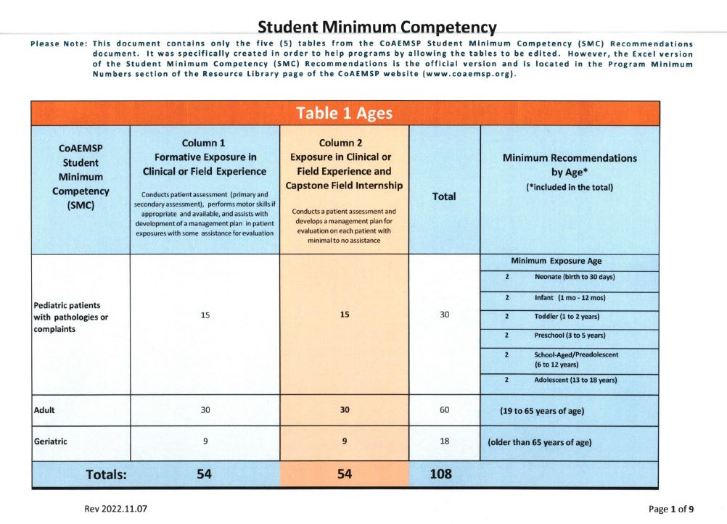

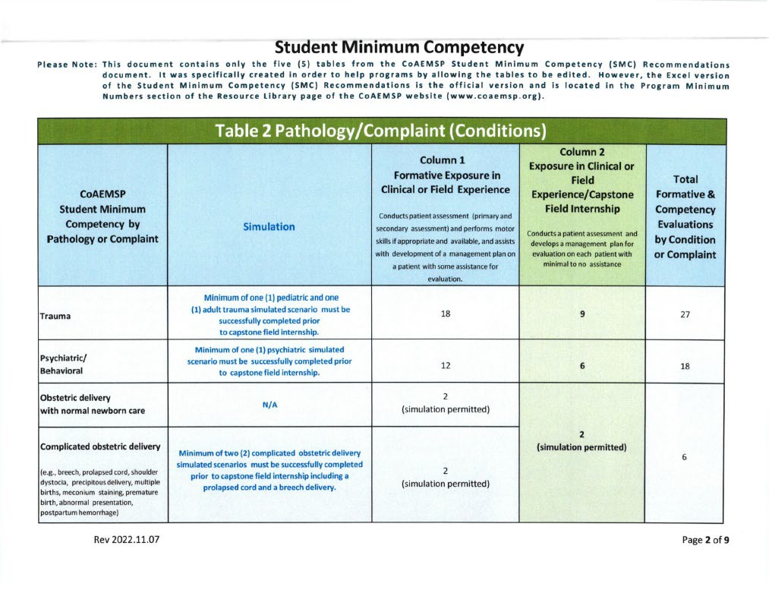

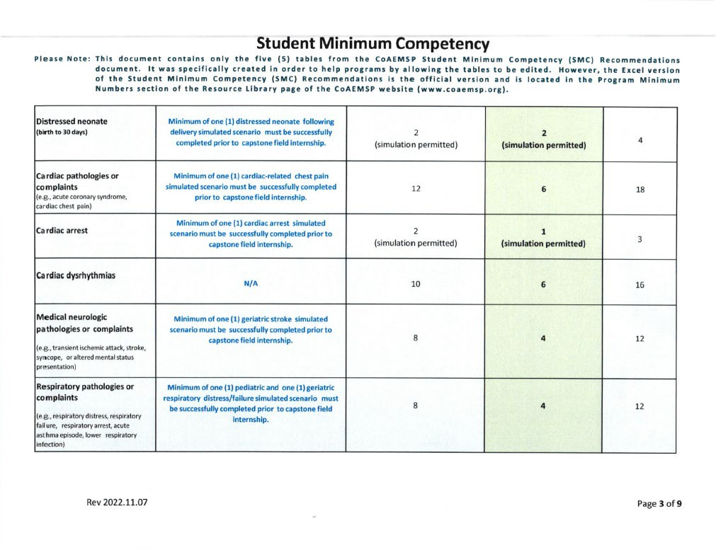

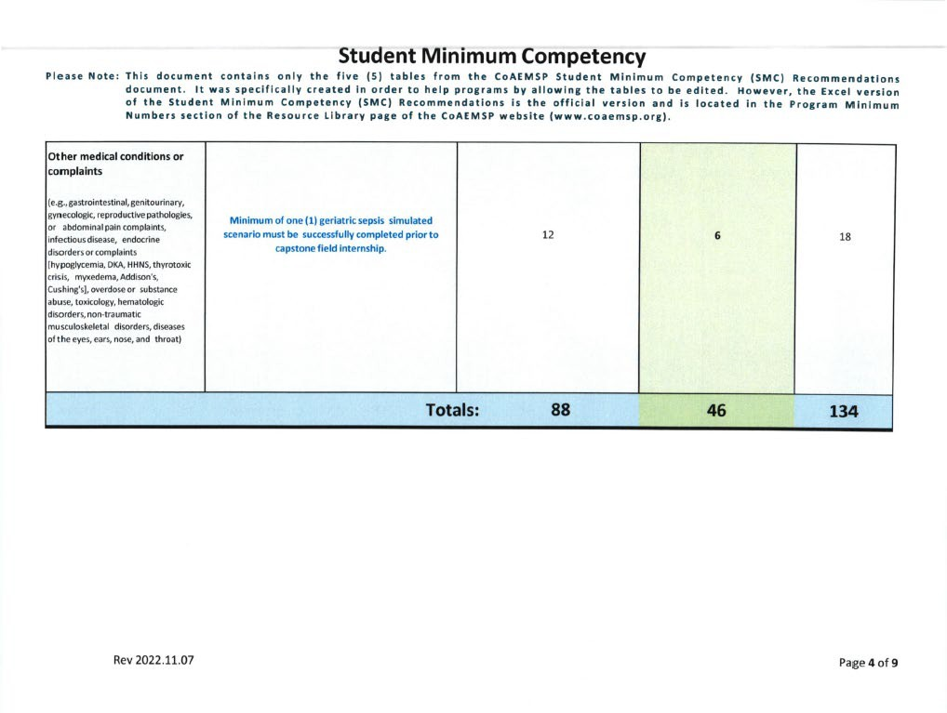

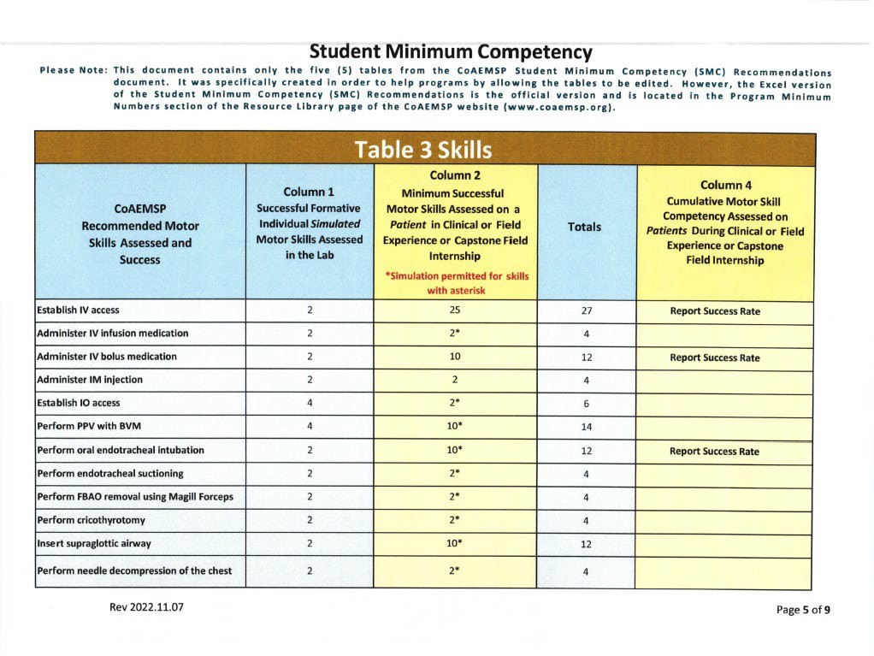

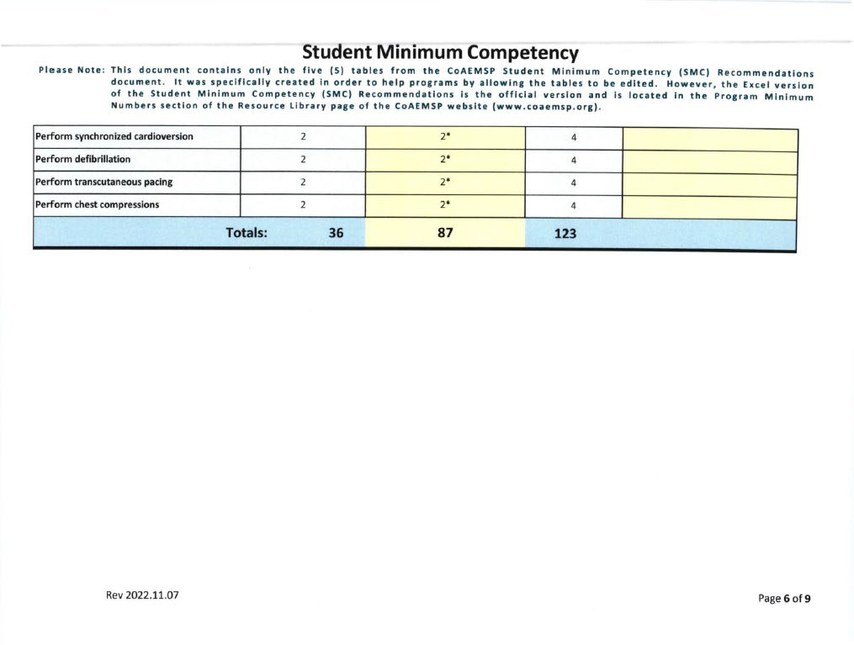

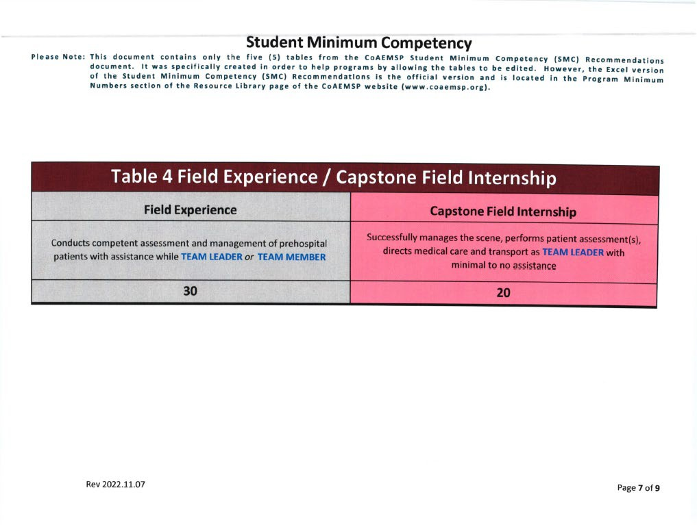

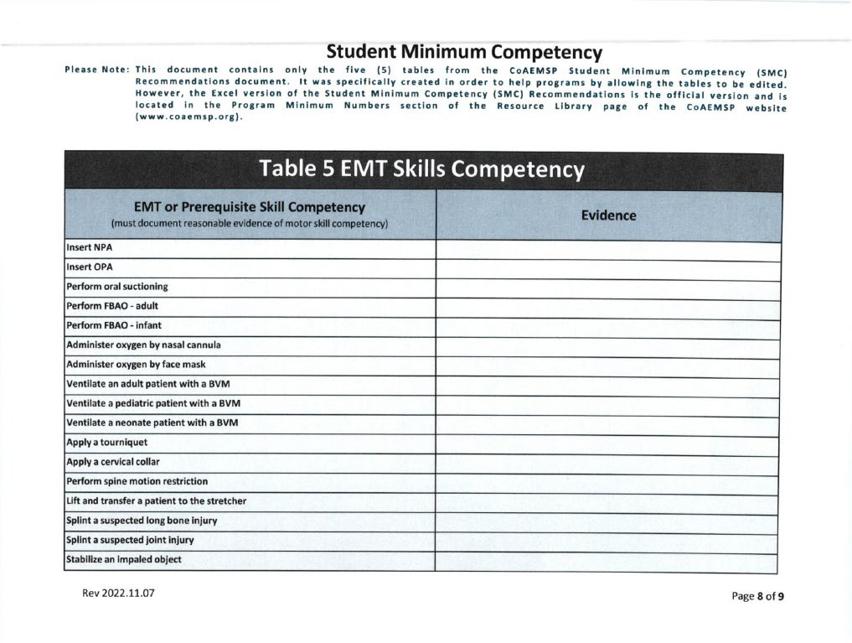

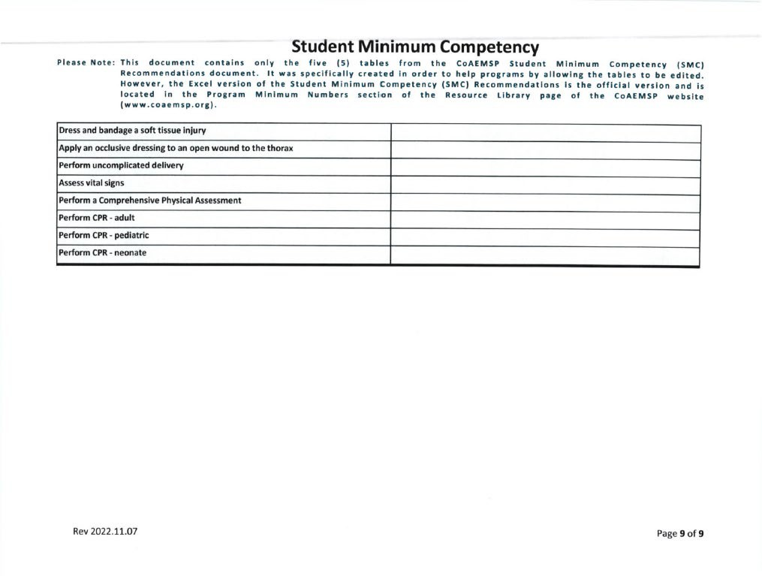

Paramedic Clinical & Field Requirements Hours:

PARAMEDIC SHIFT CLASS Clinical/field Requirements
EMSP 1161 Paramedic Clinical I | Hours | Comments
911 EMS Ambulance | 36
Emergency Room - Adult | 24
Emergency Room/Clinic - Pediatric | 12
Labor & Delivery | 12
Operating Room – Minimum (2) Live Intubations | 12
Total | 96 | Due: Fall Semester
Labor & Delivery | 8
Total | 104
EMSP 1162 Paramedic Clinical II
911 EMS Ambulance | 24
Emergency Room - Adult | 24
Emergency Room/Clinic - Pediatric | 8
Intensive Care - ICU/CCU | 24
Cardiac Cath Lab | 8
Labor & Delivery | 8 | Due Before beginning Spring  Break
Total | 96
EMSP 1163 Paramedic Clinical III
911 EMS Ambulance | 0
Adult Emergency Room | 36
Emergency Room/Clinic - Pediatric | 8
Intensive Care - ICU/CCU | 24
Labor & Delivery | 12
Nursing Home/ Psych | 16
Total | 96 | Due Before Spring Semester Final

REST OF THE PAGE LEFT BLANK INTENTIONALLY

Paramedic Practicum Field Requirements Recommendations (Student Minimum Competencies):

Age of Patients | Required #’s |  | Pathology/Complaint | Required #’s |  | Successful  Motor Skills | Required #’s
Pediatrics  0-18 years | 15 |  | Trauma | 9 |  | IV infusion medications | 2
Adult  19-64 years | 30 |  | Psych/Behavioral | 6 |  | IM injection | 2
Geriatrics  65 and older | 9 |  | OB Delivery | 2 |  | IO Access | 2
 |  |  | Distressed neonate | 2 |  | PPV w/ BVM | 10
 |  |  | Cardiac complaint | 6 |  | ETT suction | 2
 |  |  | Cardiac arrest | 1 |  | FBAO removal w/ Magill forcep | 2
 |  |  | Cardiac dysrhythmia | 6 |  | Cricothyrotomy | 2
Successful Attempts | Required #’s |  | Neurological | 4 |  | Supraglottic Airway | 10
IV Access | 25 |  | Respiratory | 4 |  | Needle decompression | 2
IV bolus medications | 10 |  | Other medical | 6 |  | Synchronized  Cardioversion | 2
Endotracheal Intubation | 10 |  |  |  |  | Defibrillation | 2
 |  |  |  |  |  | Pacing | 2
Capstone  Team Leads | 20 |  |  |  |  | Chest compressions | 2

Section 12.09 Clinical Paperwork

Paramedic Student Clinical & Field Internship Handbook:
All students must complete all required documentation in their clinical/field internship handbook(s). All documents are considered complete when:
- The Hill College EMS Program Paramedic Clinical Handbook Acknowledgment page is signed and dated by the student and returned to the Clinical Coordinator prior to beginning clinical/field internship.
- Ambulance Objectives with preceptor and student signatures.
- Emergency Department Objectives with preceptor and student signatures.
- Pediatric Emergency Room Objectives with preceptor and student signatures.
- Labor and Delivery Objectives with preceptor and student signatures.
- Intensive Care ICU/CCU Objectives with preceptor and student signatures.
- Cardiac Cath Lab Objectives with preceptor and student signatures.
- Operating Room (with at least 2 live intubations), Objectives with preceptor and student signatures.
- Nursing Home/Psych Objectives with preceptor and student signatures.
- Patient encounter log with at least 5 patient contacts.
- Patient encounter form – Patient report of patient. To include preceptor and student signatures.
- Student Evaluation of a clinical site. To include student signature and date.
- Student Evaluation of self. To include student signature and date.
- Students shall enter all documentation in the FISDAP Scheduler within 24 hours of their scheduled clinical or field rotation. See Section 12.09 Clinical Grading Policy.

Students who fail to complete all Clinical guidelines in Section 12.02 will not meet the requirements for successful completion of their Hill College EMS Program EMT ADVANCED/PARAMEDIC Basic course.
- Students will not be eligible to take the National Registry of Emergency Medical Technician for Paramedic certification.
- Falsification of clinical documentation will be considered Academic Dishonesty and grounds for immediate removal from the program.
- Clinical and field preceptors must sign all required Paramedic Student Handbook documents.
- It is the student's responsibility to retain copies of all clinical documentation.

Clinical & Field Internship Completion:
- Paramedic Shift class consists of two 16-week and one 11-week course.
- Paramedic Night class consists of three 16-week courses and one 11-week course.
- Paramedic students shall schedule the required number of clinical and field internship rotations to complete the requirements as follows:
  - EMSP 1161 – Prior to the beginning of the Second semester of classes.
  - EMSP 1162 – Prior to beginning of Spring Break Holiday
  - EMSP 1163 – Prior to the scheduled written semester final exams.
  - EMSP 2460 (Capstone) – Prior to the end of the 11–week summer semester (this is to include extra shifts given).
- Students who fail to meet the clinical and field internship deadlines will be subject to removal from the Hill College EMS Program.
- The Clinical Coordinator or EMS Program Director may allow the extension of clinical and field internship completion based on available clinical and field internship opportunities during the semester.
- Students failing to meet the requirements in Section 10.04 will not be given extended time to complete their requirements for EMSP 1161,1162, 1163, and 2460.

Upon successful completion of all required clinical and field internship rotations, the student shall return the clinical and field internship handbook(s) to the Clinical Coordinator. The EMS Program Director will then clear the paramedic student to test with the National Registry of Emergency Medical Technicians Paramedic (NREMT).

Rest of Page Left Blank Intentionally

Section 12.10 Clinical & Field Internship Grading Policy

Purpose:
It is the intent of the Hill College EMS Program to produce competent entry level providers. Clinical case studies are critical to the understanding of EMS and give the student both the clinical reference of physiological conditions, as well as basis for an understanding of treatment modalities.
It is the student’s responsibility to apply the knowledge presented throughout this course through well documented case studies. The students should understand they might not all have the opportunity to participate in the treatment of sick or injured patients. With that understanding, the student should make every effort to document what they have encountered.
Case Studies that have been turned in late:
- All late case studies shall be assessed with a 10-point deduction for every day the case study is turned in late for that semester.
- All case studies that are tuned in after the semester will receive no clinical grade for the enrolled clinical/field internship courses of instruction. The students will be considered unsuccessful with their requirements for graduation from the Hill College Paramedic Program.

All case studies will be evaluated in the following areas:
Content Quantity (20%): Based on the amount of information provided by the student:
5 Points: The student provided no information.
10 Points: Information provided is non-descriptive and contains errors. 15 Points: Information provided is limited; one-to-two-word answers. 20 Points: Information provided is detailed and descriptive.
Content Quality (20%): Based on the relevance of information contained:
5 Points: The student provided no information.
10 Points: Information provided is not clinically relevant to the assessment and treatment of the patient. 15 Points: Information provided is clinically relevant to the assessment and the treatment of the patient with limited and non-descriptive documentation.
20 Points: Information provided is clinically relevant, and it provides insight into the patient’s condition at the time of assessment and treatment.
Clinical Clarity (20%): Based on the overall organization of the document and its contents:
5 Points: No information provided by the student.
10 Points: Information was unorganized, confusing, usage of incorrect terms, ideas, concepts, or treatments.
15 Points: Information was organized but provided limited insight.
20 Points: Information is well organized, provides clinically relevant data, terms, ideas, concepts, and treatments.
Acceptability (20%): Based on overall neatness and professional presentation:
5 Points: Information provided was illegible and could not be deciphered.
10 Points: Information provided was unorganized; it contains 3 or more errors.
15 Points: Information provided was neat; contains 1-2 spelling errors.

20 Points: Information provided was neat with proper spelling or error corrections.
Document Completion (20%): Based on the overall completion of the case study with supporting documentation, which includes 3-lead or 12-lead EKGs, vitals, assessment findings, etc.:
5 Points: Document is incomplete & lacks signatures and supporting documentation.
10 Points: Document doesn’t have all fields completed.
15 Points: Document has all fields complete, but no supporting information.
20 Points: Document has all fields completed and supporting documentation.

Rest of Page Left Blank Intentionally

Article 13 EMS Education Program Information

Section 13.01 Program Length and Description
EMT (Lecture/Lab)
EMSP 1501- College Credit/Continuing Education EMT Clinical (Clinical)
EMSP 1160 - College Credit Continuing Education
The following are EMSP co-requisite courses that must be taken in conjunction with each other during the semester:
EMSP 1501 Emergency Medical Technician EMSP 1160 EMT Basic Clinical
The following courses are offered by the Hill College EMS Education Program towards certification/licensure as a Paramedic in Texas. There are academic courses required outside of the EMS department for the Certificate programs and Associates in Applied Science (A.A.S.) degree plan. Please refer to the current Hill College Catalog: https://www.hillcollege.edu/academics/index.html. The Hill College Paramedic program is 3 semesters in length: fall, spring, and summer.
- EMSP 1160 Basic Clinical Internship
- EMSP 1161 Intermediate Clinical
- EMSP 1162 Paramedic Clinical I
- EMSP 1163 Paramedic Clinical II
- EMSP 1355 Trauma Management
- EMSP 1356 Patient Assessment & Airway Management
- EMSP 1438 Introduction to Advanced Practice
- EMSP 1501Emergency Medical Technician
- EMSP 2143 Assessment Based Management
- EMSP 2338 EMS Operations
- EMSP 2348 Emergency Pharmacology
- EMSP 2430 Special Populations
- EMSP 2434 Medical Emergencies
- EMSP 2460 Paramedic Clinical III
- EMSP 2544 Cardiology
- BIOL 2401Anatomy & Physiology I (Certificate of Completion) & higher (Required for A.A.S.)
- BIOL 2402 Anatomy & Physiology II (Certificate of Technology) & higher (Required for A.A.S.)
- ENGL 1301 English Composition I (Required for A.A.S.)
- ENGL 2311Technical Writing (Required for A.A.S.)
- PSYC 2301 General Psychology (Required for A.A.S.)
EMSP 1160 Basic Clinical Internship-E.M.S. Professions (0-6)
A method of instruction providing detailed education, training and work-based experience, and direct patient/client care, generally at a clinical site. Specific detailed learning objectives are developed for each course by the faculty. On-site clinical instruction, supervision, evaluation, and placement are the responsibilities of the college faculty. Clinical experiences are unpaid external learning experiences. Courses may be repeated if topics and learning outcomes vary.
Prerequisite/co-requisite: Must be Eighteen years of age to obtain TDSHS EMT-Basic certification.

Must have obtained a GED or high school diploma prior to testing with the National Registry of Emergency Medical Technicians.

EMSP 1161 Advanced Clinical-E.M.S. Professions (0-6)
A method of instruction providing detailed education, training and work-based experience, and direct patient/client care, generally at a clinical site. Specific detailed learning objectives are developed for each course by the faculty. On-site clinical instruction, supervision, evaluation, and placement are the responsibilities of the college faculty. Clinical experiences are unpaid external learning experiences. Courses may be repeated if topics and learning outcomes vary. Prerequisite: Completion of introduction to Advanced Practices to include airway management and intravenous infusion therapy.
EMSP 1162 Paramedic Clinical 1-E.M.S. Professions (0-6)
A method of instruction providing detailed education, training and work-based experience, and direct patient/client care generally at a clinical site. Specific detailed learning objectives are developed for each course by the faculty. On-site clinical instruction, supervision, evaluation, and placement are the responsibilities of the college faculty. Clinical experiences are unpaid external learning experiences. Clinicals may be repeated if topics and learning outcomes vary. Prerequisite/co-requisite: Completion of Introduction to Advanced Practices to include airway management and intravenous infusion therapy and emergency pharmacology.

EMSP 1163 Paramedic Clinical II-E.M.S. Professions (0-6)
A method of instruction providing detailed education, training and work-based experience, and direct patient/client care, generally at a clinical site. Specific detailed learning objectives are developed for each course by the faculty. On-site clinical instruction, supervision, evaluation, and placement are the responsibilities of the college faculty. Clinical experiences are unpaid external learning experiences. Course may be repeated if topics and learning outcomes vary. Prerequisite:
Completion of Paramedic I and Assessment Based Management.

EMSP 1355 Trauma Management (2-2)
A detailed study of the knowledge and skills necessary to reach competence in the assessment and management of patients with traumatic injuries. Prerequisite: Patient Assessment & Advanced Airway.

EMSP 1356 Patient Assessment & Airway Management (2-2)
A detailed study of the knowledge and skills required to reach competence in performing patient assessment and airway management. Prerequisite: EMT ADVANCED/PARAMEDIC Introduction to Advanced Practice.

EMSP 1438 Introduction to Advanced Practice (3-2)
An exploration of the foundations necessary for mastery of the advanced topics of clinical practice out of the hospital. Prerequisite: EMT.

EMSP 1501 Emergency Medical Technician (3-8)
Introduction to the level of Emergency Medical Technician (EMT). Includes all the skills necessary to provide emergency medical care at a basic life support level with an ambulance service or other specialized services. Prerequisite/co-requisite: Must be eighteen years of age to obtain TDSHS EMT-Basic certification. Must have attained a GED or high school diploma prior to testing with the National Registry of Emergency Medical Technicians.

EMSP 2143Assessment-Based Management (0-3)
The capstone of the EMSP program. Designed to provide teaching and evaluating comprehensive assessment-based patient care management. Prerequisite: Patient Assessment & Advanced Airway, Trauma, Cardiology, Medical Emergencies, Special Populations.
EMSP 2338 EMS Operations (2-2)
A detailed study of the knowledge and skills necessary to safely manage the scene of an emergency. Prerequisite: Paramedic I & II.

EMSP 2348 Emergency Pharmacology (3-1)
A comprehensive course covering all aspects of the utilization of medications in treating emergency situations. The course is designed to complement Cardiology, Special Populations, and Medical Emergency courses. Co-requisite: Introduction of Advanced Practices, Patient Assessment and Airway Management, Trauma Management.

EMSP 2430 Special Populations (3-2)
A detailed study of the knowledge and skills necessary to reach competence in the assessment and management of ill or injured patients in non-traditional populations. Prerequisite: Patient Assessment & Advanced Airway, Pharmacology, Cardiology, and Medical Emergencies.

EMSP 2434 Medical Emergencies (3-4)
A detailed study of the knowledge and skills necessary to reach competence in the assessment and management of patients with medical emergencies. Prerequisite: Patient Assessment & Advanced Airway, Pharmacology, and Cardiology.
EMSP 2460 Clinical-Emergency Medical Service Professions III (Capstone) (0-16)
A method of instruction providing detailed education, training and work-based experience, and direct patient/client care, generally at a clinical site. Specific detailed learning objectives are developed for each course by the faculty. On-site clinical instruction, supervision, evaluation, and placement are the responsibilities of the college faculty. Clinical experiences are unpaid external learning experiences. Course may be repeated if topics and learning outcomes vary. Prerequisite/co-requisite: Completion of Paramedic I & II along with EMS Operations.

EMSP 2544 Cardiology (4-4)
A detailed study of the knowledge and skills necessary to reach competence in the assessment and management of patients with cardiac emergencies. Co-requisite: Patient Assessment, Advanced Airway & Emergency Pharmacology.

Section 13.02 Program Cost
The cost of the program is based on the current tuition and fees schedule as posted on the Hill College website/EMS Program webpage.

Please contact Enrollment Management for further questions regarding tuition and fees.

Section 13.03 Physical Requirements
Students will be required to perform certain job functions that may require the student to be able to carry at least 120 lbs. Another requirement for employment in EMS is extended hours without sleep. To prepare the student for these tasks, each student may be required to perform physical exercise to include but not limited to:
- Push ups
- ·Sit ups
- Leg lifts
- Walking with patients, equipment, and supplies over various terrains
- Perform CPR for extended periods of time (not to exceed 6o min)
- Remain at a clinical rotation site for 24 hours while completing ambulance rotations

Rest of Page Left Blank Intentionally

Article 14 Secretary Commission on Achieving Necessary Skills (SCANS)
SCANS Skills: This syllabus meets all Differentiated Entry Level Competencies and Secretary Commission on Achieving Necessary Skills (SCANS) competencies, which are identified throughout all syllabi. Please refer to the Scans chart for further clarification.

FOUNDATION
Basic Skills: Reads, writes, performs arithmetic and mathematical operations, listens, and speaks.
F1 Reading | Locates, understands, and interprets written information in prose and in documents such as manuals, graphs, and schedules.
F2 Writing | Communicates thoughts, ideas, information, and messages in writing; creates documents such as letters, directions, manuals, reports, graphs, and flow  charts.
F3 Arithmetic | Performs basic computations; uses basic numerical concepts such as whole numbers, etc.
F4 Mathematics | Approaches practical problems by choosing appropriately from a variety of mathematical techniques.
F5 Listening | Receives, attends to, interprets, and responds to verbal messages and other cues.
F6 Speaking | Organizes ideas and communicates orally.
Thinking Skills: Thinks creatively, makes decisions, solves problems,
visualizes, knows how to learn, and reasons.
F7 Creative Thinking | Generates new ideas
F8 Decision Making | Specifies goals and constraints, generates alternatives, considers risks, and evaluates and chooses best alternative.
F9 Problem Solving | Recognizes problems and devises and implements plan of action.
F10 Seeing Things in the Mind’s Eye | Organizes and processes symbols, pictures, graphs, objects, and other  information.
F11 Knowing How to Learn | Uses efficient learning techniques to acquire and apply new knowledge and skills.
F12 Reasoning | Discovers a rule or principle underlying the relationship between two or more objects and applies it when solving a problem.
Personal Qualities: Displays responsibility, self-esteem, sociability, self-management, integrity, and honesty
F13 Responsibility | Exerts a high level of effort and perseveres towards goal attainment.
F14 Self-Esteem | Believes in own self-worth and maintains a positive view of self.
F15 Sociability | Demonstrates understanding, friendliness, adaptability, empathy, and politeness in group settings.
F16 Self-Management | Assesses self accurately, sets personal goals, monitors progress, and exhibits self-control.
F17 Integrity/Honesty | Chooses ethical courses of action.
COMPETENCY

Resources: Identifies, organizes, plans,
and allocates resources.
C1 Time | Selects goal-relevant activities, ranks them, allocates time, and prepares and  follows schedules.
C2 Money | Use or prepares budgets, makes forecasts, keeps records, and adjusts meet  objectives.
C3 Materials and Facilities | Acquires, stores, allocates, and uses materials or space efficiently
C4 Human Resources | Assesses skills and distributes work, accordingly, evaluates performance, and  provides feedback.
Information: Acquires and uses information.
C5 | Acquires and evaluates information.
C6 | Organizes and maintains information.
C7 | Interprets and communicates information.
C8 | Uses computers to process information.
Interpersonal: Works with others.
C9 Participates as a member of a team | Contributes to group effort.
C10 | Teaches others new skills.
C11 Serves Clients/Customers | Works to satisfy customer’s expectations.
C12 Exercises Leadership | Communicates ideas to justify position, persuades and convinces others,  responsibly challenges existing procedures and policies.
C13 Negotiates | Works toward agreements involving exchange of resources; resolves  divergent interests.
C14 Works with Diversity | Works well with men and women from diverse backgrounds.
Systems: Understands complex interrelationships.
C15 Understands Systems | Knows how social, organizational, and technological systems work and operates  effectively with them.
C16 Monitors and Corrects Performance | Distinguishes trends, predicts impacts on system operations, diagnoses system’s  performance, and corrects malfunctions.
C17 Improves or Design Systems | Suggests modifications to existing systems and develops new or alternative  systems to improve performance.
Technology: Works with a variety of technologies
C18 Selects Technology | Chooses procedures, tools or equipment, including computers and related  technologies
C19 Applies Technology to Task | Understands overall intent and proper procedures for setup and operation of  equipment.
C20 Maintains and Troubleshoots  Equipment | Prevents, identifies, or solves problems with equipment, including computers  and other technologies.

Hill College
Emergency Medical Services Program
Article 15 Student Contract
These procedures prescribe standards of conduct for students enrolled in the Hill College EMS Program. I understand that this handbook contains information about the guidelines and procedures of the Hill College EMS Program in which I am enrolled. I also understand that I can find information about the general college policies in the Hill College Catalog. I may find information specific to each Allied Health Program from the Program Coordinator, program faculty, program website, course syllabi, and course outline.
The Hill College EMS Program guidelines are in addition to those prescribed for students under Hill College’s policies and administrative regulations. Violation of any such standard may serve as grounds for program dismissal, suspension, or other discipline.
Every student is expected to know and comply with all current policies, rules, and regulations as printed in the class schedule, college student handbook, and specific Hill College EMS Program student handbook guidelines. Copies of the Hill College EMS Program Handbook are available from the EMS Program Coordinator.
By signing this agreement, I certify that I have received a copy of the Paramedic Student Handbook, read and understand the EMS student guidelines and will meet the policies of the Hill College EMS Program.

Student's Name (printed)

Student's Signature Date

Witness Name (printed)

Witness Signature Date

Faculty Signature and Title Date

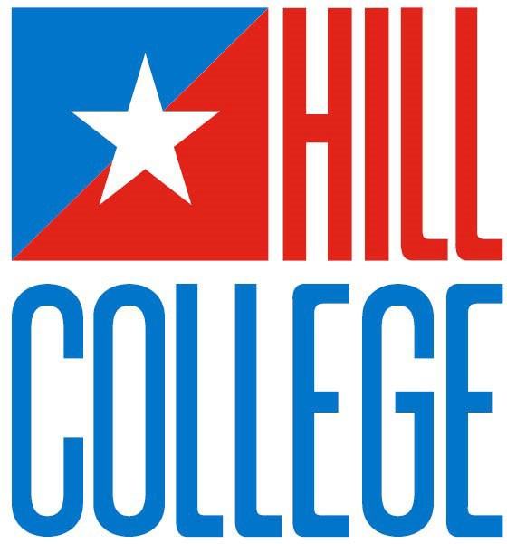
EMS Program Preceptor Education

2025-2026

Johnson County Campus|2112 Mayfield Parkway|Cleburne, TX 76033

Burleson Higher Education Center | 517 SW Johnson | Burleson, TX 76028

Hill County Campus | 112 Lamar Dr. | Hillsboro, TX 76645




Hill College EMS Preceptor Education
All are accessible via a computer or a cell phone.

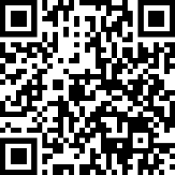 | Jot Form Submission  Use this code to access the quiz to complete the training. Upon completion of the training, you will receive a completion PDF.  https://form.jotform.com/HillCollege/PreceptorTraining

Links to the PDF and/or PowerPoint for Preceptor Education Training
EMS Program Preceptor Education PowerPoint  https://view.officeapps.live.com/op/view.aspx?src=https%3A%2F%2Fwww.hillcollege.edu%2F Courses%2520and%2520Programs%2FHealthPublicSvc%2FHPS-Files%2Fpreceptor-hold%2FPreceptorEducation.pptx&wdOrigin=BROWSELINK | 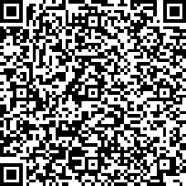

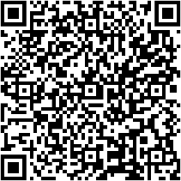 | EMS Program Preceptor Education PDF  https://www.hillcollege.edu/Courses%20and%20Programs/HealthPublicSvc/HPS-Files/preceptor-hold/EMS-Program-preceptor-training.pdf

Thank you for your continued support of our students.

ROLES and RESPONSIBILITIES

Preceptor Responsibilities
Effective preceptors possess skills as role models, teachers, mentors, counselors, and evaluators. Preceptors have multiple responsibilities, but the most important is modeling professional and ethical behaviors for the sometimes young and often impressionable students. Other responsibilities include:
    - Sharing knowledge and experiences
    - Developing rapport with students that leads to:
    - Frequent and frank communication
    - Clear and understandable expectations
    - Creating a safe learning environment
    - Building student confidence to enhance learning and independence.
    - Completing written evaluations in a timely manner
    - Communicating student needs, deficiencies, and progress with HILL COLLEGE EMS PROGRAM faculty
    - Making recommendations regarding student abilities to meet all objectives.

Intern or Student Responsibilities
Self- regulation
    - Students must assume personal responsibility for acquiring their knowledge and skills. They must develop processes that enable them to manage, organize, and apply classroom knowledge while they perfect the difficult tasks of analyzing, problem solving, and priority setting.
    - Because self-regulation comes from within, it requires active self-motivation not prompted by others.
    - Students must continuously work toward the goals of internship, monitoring their progress, checking for outcomes, and then redirecting their efforts when needed.
Ask questions and seek clarification and guidance. Ask for feedback and ask for ways to improve.
Be receptive to feedback.
Accept responsibility for his/her actions. Communicate his/her needs to the preceptor.
Assist with any and all station chores after first stocking and cleaning the ambulance. Be a station team member.
Be honest and courteous with all interactions.

Hill College EMS Program Responsibilities
Contact the paramedic driver or station officer by phone a minimum of 3 times during internship to follow progress.
On an as needed basis, before a student arrives on the first shift, inform preceptors of performance areas where the student may need assistance.
Analyze information relayed by preceptors to determine if students are or are not meeting internship objectives and goals.
On an as needed basis, accompany preceptors and students on actual patient calls to assist in assessment of student performance.
On an as needed basis, assist paramedics with completion of performance evaluations.
Meet with paramedics and students to develop goals for improvement and/or to determine if additional shifts are needed. Decide whether additional internship shifts are needed.
Consult with medical directors regarding the need for additional shifts. Assimilate, organize, and evaluate all student paperwork.

CURRICULUM CHANGES and PROFESSIONALISM

Increasing Knowledge
EMS education is governed by state EMS rules and national EMS education standards.
New standards will be adding content and depth to round out knowledge base in the areas of pharmacology, anatomy and physiology, decision making, etc.
In 1999, changes were also made to the national curriculum which focused on all three domains of learning (cognitive, psychomotor, and affective). The following represents their application to internship:
    - Cognitive learning occurs when students apply classroom knowledge while analyzing, problem solving, and setting priorities for real patients.
    - Psychomotor learning occurs when students apply basic and advanced skills to real patient situations.
    - Affective learning focuses on the professional attitudes needed to transition from the role of learner to caregiver. During internship, students will be evaluated for their reception to feedback, communication skills, and appreciation for patients and their many predicaments.

Professional Behaviors
EMS educators and employers recognize that developing and maintaining acceptable professional attitudes are important because:
    - Good attitudes typically lead to better patient care.

    - Poor attitudes poison peers and can lead to widespread job dissatisfaction and poor patient care.
    - Negative comments by employees can negatively impact public opinion of an organization.
    - Those with professional behavior are better at accepting and adapting to change within an organization, especially changes in treatment and protocols.
To address the importance of professional behaviors, the national curriculum now includes lectures on ethics, therapeutic communication, roles and responsibilities, etc. It also stresses helping students develop and maintain eleven key professional behaviors. As a preceptor, you, too, have the ability to hold student behavior to a higher standard and call attention to behavior that is deficient in any of the following eleven professional behaviors:
- Integrity
Examples of professional behavior include but are not limited to: Consistent honesty; being able to be trusted with the property of others; being able to be trusted with confidential information; complete and accurate documentation of patient care and learning activities; personal accountability including acknowledgment of personal errors, omissions and limitations.
- Empathy
Examples of professional behavior include but are not limited to: Showing compassion for others; responding appropriately to the emotional response of patients and family members; demonstrating respect to others; demonstrating a calm, compassionate, and helpful demeanor toward those in need; being supportive and reassuring to others.
- Self-Motivation
Examples of professional behavior include but are not limited to: Taking initiative to complete assignments, taking initiative to improve and/or correct behavior; taking on and following through on tasks without constant supervision; showing enthusiasm for learning and improvement; consistently striving for excellence in all aspects of patient care and professional activities; accepting constructive feedback in a positive manner; taking advantage of learning opportunities; thoroughness and completeness in work.
- Appearance and Personal Hygiene
Examples of professional behavior include but are not limited to: Clothing and uniform is appropriate, neat, clean, and well maintained; good personal hygiene and grooming.
- Professional Maturity / Self-Confidence
Examples of professional behavior include but are not limited to: Demonstrating the ability to trust personal judgment; demonstrating an awareness of strengths and limitations; accepting positive feedback and taking responsibility for actions; exercising good personal judgment.
- Communications/Critical Thinking
Examples of professional behavior include but not limited to: Speaking clearly; writing legibly; listening actively; adjusting communication strategies to various situations; demonstrating logical thinking skills.
- Time Management
Examples of professional behavior include but are not limited to: Following the published schedule, consistent punctuality; completing required hours, tasks, and assignments in a timely manner, adhering to published clinical

schedule.
- Teamwork and Diplomacy
Examples of professional behavior include but not limited to: Placing the success of the team above self-interest; not undermining the team; helping and supporting other team members; showing respect to all team members; remaining flexible and open to change; communicating with others to resolve problems; cooperation and flexibility.
- Respect
Examples of professional behavior include but are not limited to: Being polite to others; not using derogatory or demeaning terms; behaving in a manner that brings credit to the profession; following instructor instructions; listening in class, being punctual to all classes; not sleeping in class. These policies of respect apply to fellow students, hospital personnel, station personnel, and patients, without regard to race, color, national origin, religion, sex, sexual orientation, veteran status or handicap.
- Patient Advocacy/Support/Backing
Examples of professional behavior include but are not limited to: Not allowing personal bias or feelings to interfere with patient care; placing the needs of patients above self-interest; protecting and respecting patient confidentiality and dignity; confidentiality of privileged information.
- Careful Delivery of Service
Examples of professional behavior include but are not limited to: Mastering and refreshing skills; performing complete equipment checks; demonstrating careful and safe ambulance operations; following policies, procedures, and protocols; following orders.
How can you help students develop the professionalism that leads to better patient care?
  - Model the right behavior – students idolize you and will mimic your actions and follow in your footsteps.
  - Maintain a positive attitude about EMS when discussing its difficulties.
  - Let students know when their behavior is inappropriate – saying nothing lets the student think it is normal and acceptable.
  - Convey to the student that complaining, derogatory comments, and inappropriate patient care break down the resiliency of everyone – Many paramedics know how difficult it can be to provide patient care while working with a partner with a negative attitude. Redirecting negative comments early may have an impact on future comments and actions.
  - Inform HILL COLLEGE EMS PROGRAM faculty if your efforts to change student behavior are not working; we can come to the station and initiate a formal written evaluation.

This is your intern’s third time arriving late for work. He received a great deal of agitation after being late the second time, and you asked that he not be late in the future. Today he is 25 minutes late and says he got caught in traffic. He does a good job of stocking the ambulance and is making progress in history taking and decision making. What should you do?

LEARNING THROUGH PHASES
For most individuals, the act of learning occurs in steps or phases. For example, the process of learning the respiratory system and its disease processes begins in EMT school, with layers of additional learning added along the way. Below is an example of phases one might undergo while learning about the respiratory system and its diseases.
EMT level – basic airway structures are learned which include the nose, mouth, tongue, pharynx, larynx, bronchi, bronchioles, and alveoli, as well as very basic signs and symptoms of the most common respiratory diseases.
Anatomy and Physiology course – Additional respiratory detail to include cilia, acid-base regulation, endothelial mucosa and secretions, etc. is added to the basics learned in EMT class.
Paramedic level – Advanced physiology learned in the anatomy and physiology course is linked to detailed pathophysiology and signs and symptoms of multiple airway diseases; more advanced respiratory diseases such as cor pulmonale and pulmonary hypertension are also added.
Clinical Rotations – With the help of respiratory therapists, nurses, physicians, and paramedic technicians, students apply classroom knowledge as they observe and treat patients with respiratory diseases.
Internship/Preceptorship – Students use classroom information and clinical experiences to gradually become responsible for the assessment and care of patients with respiratory diseases.
Phasing is also important as students’ progress through internships. Most students cannot run calls independently on their first shifts and asking them to do so can create frustration and feelings of failure. The benefits of phasing include:
- Allows students to initially observe and form a mental picture of patient care, which is especially helpful for those who have only their EMT student ride outs to reference for past prehospital experience.
- Promotes success and feelings of confidence by grouping tasks into manageable pieces and then gradually introducing them.
- Success at a given task is an incentive to progress to higher tasks.
- Confidence is built when students are successful at some tasks on each shift.
- Provides clear goals and objectives from which to identify problems.
In this system, students phase through graduated objectives for each shift. The natural progression is that of being an observer, if necessary, then a participant, and then a team leader.
The primary goal of shifts 1 and 2 is that the students observe you demonstrate the actions and attitudes of a field paramedic. During these shifts, students are primarily observers receiving large amounts of instruction and direction from you. At your direction, they can perform any basic or advanced skill.
During shifts 3 and 4, students become involved in patient management with minimal control of non-critical patient situations. They begin functioning as team leaders on BLS calls and receive lots of directions and prompting from you. Beginning with shift 4, less emphasis is placed on basic skills.
Shift 5 is one of transition, where students demonstrate the willingness to initiate care and take control of any patient situation. The student functions as the team leader on all calls and begins the process of total call management. When needed, prompting can be used to improve performance.

During shifts 6, 7, 8, 9, and 10, students develop confidence in their roles as team leaders as they initiate and refine all aspects of patient assessment and management. By shift ten, the student is expected to come to accurate and consistent decisions regarding the management of patients without prompting from the evaluators. By shift 10, there should be little intervention or redirection by the evaluator, unless patient care is compromised.
Having said all this, there are exceptions to the above. Interns who have had EMT experience may be ready to take control much earlier. Those who are naturally shy or may not have had much hands-on experience may need pushing to achieve the internship goal.
It is your student’s first shift, and your partner tells him, “Around here we just throw you in to sink or swim. You need to get out there and get the ambulance stocked while we clean the station, and everything needs to be there when we roll out of here.”
Legally, could this be a potential problem?

How would you respond?

Verbalization - Talk as you go
Asking students to verbalize during runs and post incident care provides for an easy way to assess knowledge base, and interpret data, priority setting, etc. It also ensures all members on the call are aware of all findings and treatment, promoting more of a team approach to patient care. On the first shift, reinforce to the student that on every run, he/she needs to relay to the whole team any assessment findings, priorities, differential diagnoses, treatments etc. Additionally, ask that the student inform you of each time he/she has restocked or rechecked equipment. Examples are multiple and can include:
“She feels pressure in her chest, so I want to give her an aspirin.” “She is in respiratory failure and has rales, so can you apply CPAP?” “I put 3 more bags of normal saline on the ambulance?”
Your intern is very quiet around the station, and you have noticed he also hesitates and struggles when talking to patients. How should this be handled?

Prompts
Prompts are used to improve student performance and are an important part of the instruction and evaluation processes. They are used to prevent delays in patient care and aid the student in the assessment and treatment of patients.
They can be verbal or visual and may be as simple as asking a history question when the intern draws a blank. They should not be obvious to the patient.
Prompting occurs more frequently early in internships and should diminish substantially by shifts 6 and 7. If prompting is needed during any run, the student cannot be given credit for a successful team lead and should receive a 0 or 1 somewhere on the evaluation form. Excessive prompting in the last shifts may signal the student is not yet independent enough to function as an entry level paramedic.

Team Leads
Team Leads are a national registry requirement designed to propel the student into leadership and decision-making roles. This skill is begun in the classroom and is practiced weekly to provide a strong initial framework from which to build. A successful Team Lead occurs when the student directs, conducts, or oversees patient care. With minimal or no prompting, while keeping the crew and patients safe, the student should be able to:
    - Determine the nature of the problem and form a field impression or differential diagnosis.
    - Direct the assessment and treatment.
    - Determine the patient’s disposition.
For students to grow in the leadership role of team leader, medics must step back and let the student lead and direct. Beginning on shift 4, make sure you have spoken to the student about the role reversal – you will be doing more EMT skills so the student can lead and direct. As long as the patient’s needs are met, minimize your input and wait for the student to tell you what to do. This gives the student the true opportunity to take charge.
“He was good at standing back and letting me take full charge of the patient when it came to team lead—he is perhaps the nicest person at the entire station toward both patients and people on shift.”
Students begin the process of team leading on SHIFT 4, and 20 Team Leads are required. Of the 20 Team Leads, 10 must involve ALS runs.
An ALS run involves any call where advanced judgment/assessment has been performed and either of the following occurred:
    - On the same run, an IV and an ECG were used - OR -
    - A medication other than oxygen was administered.

DEVELOPING PROBLEM SOLVING, CRITICAL THINKING, and DECISIONMAKING SKILLS
Safe patient care depends heavily on the ability of a caregiver to solve problems, think critically, and come to accurate conclusions and decisions. Careful delivery of patient care is the result of:
- Gathering and then interconnecting data
- Integrating and interpreting data with anatomy, physiology, and pathophysiology to form a field impression or working diagnosis.
- Applying principles of treatment and care
- Evaluating the effectiveness of treatment during the call
- Reflecting, after the call, on the care given to ensure quality is present for future calls.
Many elements of thinking are needed to come to accurate conclusions and treatment. Caregivers must have cognitive skills that allow them to:

- Gather information.
- Analyze
- Reason logically
- Discriminate
- Predict
- Transfer knowledge
- Apply standards.
In addition, the following critical mind habits are needed:
- Confidence
- Creativity
- Flexibility
- Inquisitiveness
- Intuition
- Open-mindedness
- Perseverance
- Reflection
- Intellectual integrity
Most students don’t have all the aforementioned elements lined up yet, and you will need to support and guide them as they develop these intellectual processes. How can you best help with this process? Communication is key to helping in this area. Before the run, help students anticipate possibilities, during the run, prompt and offer suggestions as necessary, and after the run, discuss the student’s actions with thought provoking questions.
On the first shift, the following are good discussion points:
- Enroute, reflect on the nature of the call given by dispatch and create a mental list of possibilities behind the nature of the call. Remind them that sometimes the nature of the call given by dispatch may not in any way be related to the actual problem. Encourage them to mentally review protocol guidelines and drug doses and prepare to take in the correct equipment.
- Read the scene for safety and gather data and clues that might help define the problem.
- Look at the patient for activity, positioning, and skin color as they approach him/her.
- Assess and manage airway problems first.
- Quickly determine if the problem poses a threat to the patient’s life and determine if the patient is sick, not sick, or not yet sick. Patients at the extremes of sick and not sick are easiest to identify. Those who are not yet sick but have the potential to decline can challenge even the most experienced medics.

Sick – Does the patient have signs of sympathetic stimulation, abnormal vital signs, shock, or other signs and symptoms that their lives are at risk?

Not sick – These patients are obviously not sick, and careful assessment reveals no life-threatening or potential problems.

Not yet sick – These patients are challenging because they do not yet appear sick but have the potential to

become very sick and die. Encourage students to look closely for early signs of sympathetic stimulation and help them formulate a differential diagnosis that anticipates and monitors for potential problems.

- Investigate and determine the nature of the patient’s biggest potential problem.
- Maintain a high index of suspicion for potential life threats. Encourage them to mentally explore, “What is the worst thing that could happen to this patient while under my care?” and then treat accordingly. For example, lethal ventricular arrhythmias (V-tach and V-fib) are the primary cause of death during an acute myocardial infarction. In anticipation of these, patients need IVs and continuous ECG monitoring until they are transferred to the hospital stretcher.
- Continuously reassess and adjust treatment interventions when needed.
- Tell the student it is easy to become dependent on the computer or patient form for patient assessment; explain that you will minimize their documentation during assessment and treatment but will work with them on documentation once patient care has been transferred to the hospital.
- Help them to understand how important it is to avoid bias, which is a tendency or prejudice. It can negatively impact decision making by creating a one-way line of thinking (tunnel vision). Bias also prevents full exploration of the patient's problem, limiting assessment and sometimes denying patients the care they need.
During the run:
- Prompt only when necessary and with just enough detail to get the student moving in the right direction.
- Ask, “What would you like to do now or next?”
- If an inappropriate action is being taken by the student, ask, “What might happen if we do that?”
After the run:
- Provide some form of discussion or feedback.
- Begin by asking the student to identify his/her impression of the patient by asking, “Tell me what you thought of this patient?” This is a simple way to gain understanding of the student’s logic and problem solving.
Many questions will help develop critical thinking. Here are a few more examples:
- “Was there anything about the scene that suggested we should have taken a different course or treatment?
- “Did the treatment plan work, and how do you know if it did or did not?”
- “If the patient were younger or older, would the treatment have worked as well? Why or why not?”
- “Would this medication have worked if he was on a beta-blocker? Why or why not?”
- “What could you have done to prevent that side effect?”
- Why do you think she was having appendicitis and not an ectopic pregnancy?

COMMUNICATION and FEEDBACK
Why feedback? It shapes performance, alters outcomes, decreases anxiety, and builds confidence. Students WANT to know how their performance is viewed, both good and bad. Lack of input makes them uneasy and anxious.

“The medics I rode with were very open with me and let me know whenever there was something they thought I should fix or improve upon.”
Ideally, you want students to initiate and seek feedback regarding their performance. The best way to get students to explore their strengths and weaknesses with you is to create a friendly and safe learning environment.

Tips to open the lines of communication and put students at ease
    - Be friendly, approachable, understanding, and enthusiastic about teaching and EMS in general. Negativity about EMS not only makes students uneasy, but poisons everyone; student performance, job happiness, and patient care are all altered when any worker aggressively berates the job or public they serve.
    - Encourage exploration and questions without penalty. On the first shift, have a talk with students and let them know that o You will be giving frequent feedback, hopefully after every call.
      - No intern is perfect; all receive a combination of positive and negative feedback.
      - You don’t expect them to know everything, and becoming a confident expert in EMS takes a while.
      - It is okay and honorable to say, “I don’t know”; encourage students to ask questions when they are unsure or confused.
      - Once a weakness has been identified, the goal is to correct it and move forward.
      - You will not let them harm the patient and will intervene as needed.
    - Ask students to identify what he/she feels his/her strengths and weaknesses are.

GENERAL TIPS for successful communication
    - Be aware of your body language
    - Maintain good eye contact
    - Sit when possible,
    - Avoid folding your arms across your chest, and leave legs uncrossed o
    - Watch the gestures you use
    - Avoid pacing
    - Smile and nod your head
    - Listen Actively
    - Provide verbal clues that you are following the conversation
- I see
- Uh huh
- Yes ▪ O.K.
- Oh
    - Verbal Feedback
    - Watch the tone of your voice and pace of the conversation.
    - Clarify student responses/rationales through paraphrases and summaries.
    - “If I understand you correctly…”

    - “So, what I hear you saying is……”
    - Allow students to explain their actions through open-ended questions.

    - “Can you explain why you……”
    - Relay Positive Observations o
    - To build student confidence, ACKNOWLEDGE some positive observations every shift.
    - Acknowledge effort, even if the actions or decisions were not correct.

“There were a couple of runs on one shift where I wasn’t a shining star. Even then, those guys found something good I had done to tell me about.”

    - Timing
    - All feedback, especially negative, should be given promptly, while the events are still clear in the minds of all involved.
    - Provide some feedback after every run. When no prior feedback has been given, the impact of any negative feedback multiplies in the mind of a student.

“My preceptors evaluated my assessments, skills, reports, and written reports after each run and gave me feedback on areas where I might need some work. Their constant feedback was a big help.”

The PROCESS for relaying FEEDBACK
    - Praise in public, criticize in private – NEVER overtly correct student behavior in front of the patient, hospital personnel, or non- ambulance station personnel (with the exception of the station officer).
    - Begin in a positive manner by pointing out what went well, then sandwich in the concerning or unacceptable actions, and finally, finish again on a positive note.
    - Easy ways to introduce feedback can be to ask for the student’s own interpretation of the care he/she provided.
      - “What did you think about that patient?” o “How do you think you did with this run?”
        - “Do you have any questions regarding this patient or run?”
If with the above suggestions the student does not recognize, acknowledge or own his/her problem, then begin by asking the student to explain his/her rationale for the care they provided. This may also help to understand the decision-making process of the student. Sometimes students have a good rationale for what you think was inappropriate care; so, before telling a student what he or she did was incorrect, ask why they did what they did.
        - “Can you explain why you did not want to administer Glucose to this patient?”
        - “Can you explain why you did not obtain an ECG initially?” o “What was your rationale for moving the patient to the ambulance before applying oxygen?”
    - Next, it is important that you clarify what the student tells you by repeating back or paraphrasing key points; this ensures you heard the student correctly, and he/she knows you were listening.
    - Point out what action would have been more appropriate and then help the student explore better options for future care.
“You are on the right track, but let’s think about this…” o “Yes, a 12 Lead ECG was needed, but why do you think I redirected you to Cardiovert the patient first?”

    - Ensure the problem has been well identified with corrective behavior and goals set.
    - Conclude any negative feedback on a positive note, letting the student know there is still time to improve their performance and meet the needed objectives – even if it may take additional shifts.
    - If at any time you feel frustrated with the student’s actions or lack of, delay feedback until you can remain calm enough to communicate effectively without harsh words/judgment; take a break and provide the feedback when you are prepared to place the student’s needs in front of your own.
The actions of your intern on two back-to-back runs are concerning. On the first run, he did not want to transport an awake and alert 68-year-old woman involved in a rollover accident, and on the second run he thought a 22-yearold female with abdominal pain and a temperature of 102.2 was having an ectopic pregnancy. Describe the feedback you would give the patient.

ACCURATE DOCUMENTATION of STUDENT PROGRESS
On the evaluation forms, student performance is assessed using the following categories: NA’ = Not Applicable - not needed or expected
‘0‘= Unsuccessful - required excessive or critical PROMPTING; includes ‘Not Attempted’ when the student was expected to try
‘1’ = Marginal – inconsistent, NOT YET competent
‘2’ = Successful/Competent – NO prompting occurred
A score of ‘0’ must have a written notation added in the ‘Comment on any unsatisfactory ratings or discrepancies’ section found on the back page of the shift evaluation sheet. Sometimes we find written comments drawing vague attention to a problem, with NO marks of ‘0’ or ‘1’ to indicate the student was indeed unsuccessful or marginal. It is important that students receive marks of ‘0’ or ‘1’ when appropriate, so they know there is a problem and can fix it before the end of the internship. Do NOT be afraid to give a less than successful mark – you will be helping the student.
By the end of 10 shifts, some students have never received a ‘0’ or ‘1’ mark, indicating their performance was perfect throughout their internship. It is highly unlikely that any student is perfect during an internship. Every student should receive some marks of ‘0’ or ‘1’, especially early in the internship when they are still learning and putting things together.
For students who have failed their initial 10 shifts of internship, a mark or marks of ‘0’ must be found on the Shift 10 evaluation form. Without a mark of ‘0’, students will be considered passing.
NOTE: If students are struggling and showing no improvement with IV or intubation skills during the internship, the student can return to Parkland Hospital for more skill experience. This will be done on the student’s days off shift.

INTERNSHIP EXTENSIONS
We call frequently and thanks to your input, are usually always aware of student performance problems. We don’t mind coming to the station to ride and help with the evaluation process or help communicate problems to the student.
Ultimately, the decision to pass or assign additional shifts rests with Hill College and its medical director. Additional shifts are assigned because of known and documented deficiencies and are NOT granted so the student can gain more experience.

For additional shifts to be assigned, a ‘0’ must be found on the Tenth Shift evaluation form. Additional shifts are assigned in increments of five shifts, and daily evaluations must be completed for each shift. Additional shifts are typically due to, but not limited to, the students’ inability to:
- Perform adequate field assessments.
- Identify the chief complaint, differential diagnosis, or nature of the problem
- Recall and apply appropriate protocols.
- Set priorities.
- Anticipate medical control orders.
- Apply classroom knowledge to patient situations.
- Communicate effectively with patients.
- Accept and apply feedback.
- Perform consistently in the following areas: history taking, communication, patient assessment, treatment/transport decisions, and priority setting.
In rare instances, some students have provided adequate patient care, but preceptors have relayed that students are lacking in professional behavior (repetitively missed calls, arrived late, failed to restock the ambulance, etc.). In these cases, because the medical directors value professionalism, 5 additional shifts were ordered.

STUDENT CONFIDENTIALITY AND DATA PRIVACY LAWS
- Student privacy, like patient privacy, is governed by federal law.
- The Family Educational Rights and Privacy Act of 1974 (FERPA) prohibits the release of a student’s personally identifiable information to anyone not associated with the student’s educational process.
- For internship purposes, you CANNOT share student progress or records with
  - Non-paramedics working at the station (with the exception of the station officer).
  - Paramedics on other shifts or paramedics working for other organizations.
  - The student’s parents (all EMS students are adults over 18 years of age).
  - Hospital personnel.
  - Personal friends of the student.
  - Friends or family of you or the student.
- FERPA is interpreted and enforced by The Family Policy Compliance Office in the U.S. Department of Education.
- FERPA requires that you.
- Give student feedback privately, away from those not involved in the internship process.
- Avoid sharing student progress/educational information with station members not participating in the student’s evaluation.
- Avoid sharing student progress/educational information with hospital personnel, friends, family; student progress can be shared with HILL COLLEGE EMS PROGRAM faculty, as we are the educational institution associated with the student.
- Keep all student records confidential; access to records to outside parties can be given only with consent of the student; at age 18, students are considered adults, and parents and guardians no longer have legal rights to access student information.

- Ensure that written educational records (evaluation sheets) are kept private; avoid leaving them sitting on kitchen tables, the watch desk, etc.

You do not need to print and sign this document. Once the roster of completion is received this form will be sent to you via adobe sign from the Program. You will sign the document electronically and it will come back directly to the Program.

I, ____________________________ , acknowledge that I have been in-serviced for the Hill College EMS Program Preceptor Training. By signing this form, you have either viewed the Preceptor Training Power Point presentation, read the handout, or have been taught the material in a face-to-face format by a Hill College EMS Program Instructor or by your agency’s EMS Educator.

Signature Date

- What are the primary goals of shifts 1 and 2?
  - Students become involved in-patient management.
  - Student observation of your actions and attitudes of a field paramedic.
  - Student takes leadership roles.
  - students initiate care and control of the patient.

- When should you talk to students about verbalization?
  - Talk as you go
  - After the call only.
  - Before each call.

- Team leading begins on what shift?
  - 3rd shift
  - 2nd shift.
  - 1st shift.
  - 4th shift.

- Prompts should not occur after which shift?
  - Shift 6 & 7.
  - Shift 2 & 3.
  - Shift 4 & 5.
  - Shift 9 & 10.

- What score does the student receive if prompting occurred?
  - 2 or 3.
  - 4 or 5.
  - 0 or 1.
  - 6 or 7.

- What are the requirements for ALS team lead?
  - On the same run, an IV and an WCG were used.
  - A Medication other than oxygen was administered.
  - The student does and assessment,
  - The student watches you team lead the call.
  - Both A& B.
  - Both C & D.

- Sick, non-sick, and not yet sick is defined as?
  - Does the patient have signs of sympathetic stimulation, abnormal vital signs, shock or other signs and symptoms that their lives are at risk.
  - These patients are obviously not sic, and careful assessment reveals no life threats or potential problems.
  - These patients are challenging because they do not yet appear sick but have the potential to become very sick and die. Encourage students to look closely for early signs of sympathetic stimulation, and help them formulate a differential diagnosis that anticipates and monitors for potential problems.
  - ALL OF THE ABOVE.

- When should feedback occur?
  - Never.
  - Only when the student does something that results in negative feedback.
  - All feedback, especially negative should be given promptly, while the events are still clear in the minds of all involved.
  - Only positive feedback at end of the full shift.

- Why must negative feedback be given promptly?
  - Its fresh in everyone mind.
  - There is no need for it to be given promptly.
  - When no prior feedback has been given, the impact of any negative feedback multiplies in the mind of the student.
  - Only positive feedback at end of the full shift.
  - Both A & C.

- If a student has failed his/her internship, what must be found on the shift 10 paperwork?
  - All 2’s
  - All 1’s.
  - a mark or marks of “0”.
  - None of the above.

- A student can fail their internship based on poor attitudes and professional behavior?
  - True.
  - False.

